Headlines

In this project, you will train a computer to recognise headlines from different newspapers.

You will collect examples of the front-page headlines from different newspapers. You’ll use those to train a machine learning model that can learn from the use of language to be able to recognise which newspaper a headline is from.

You’ll also learn about the importance of testing in machine learning projects, and create a simple testing tool in Scratch.

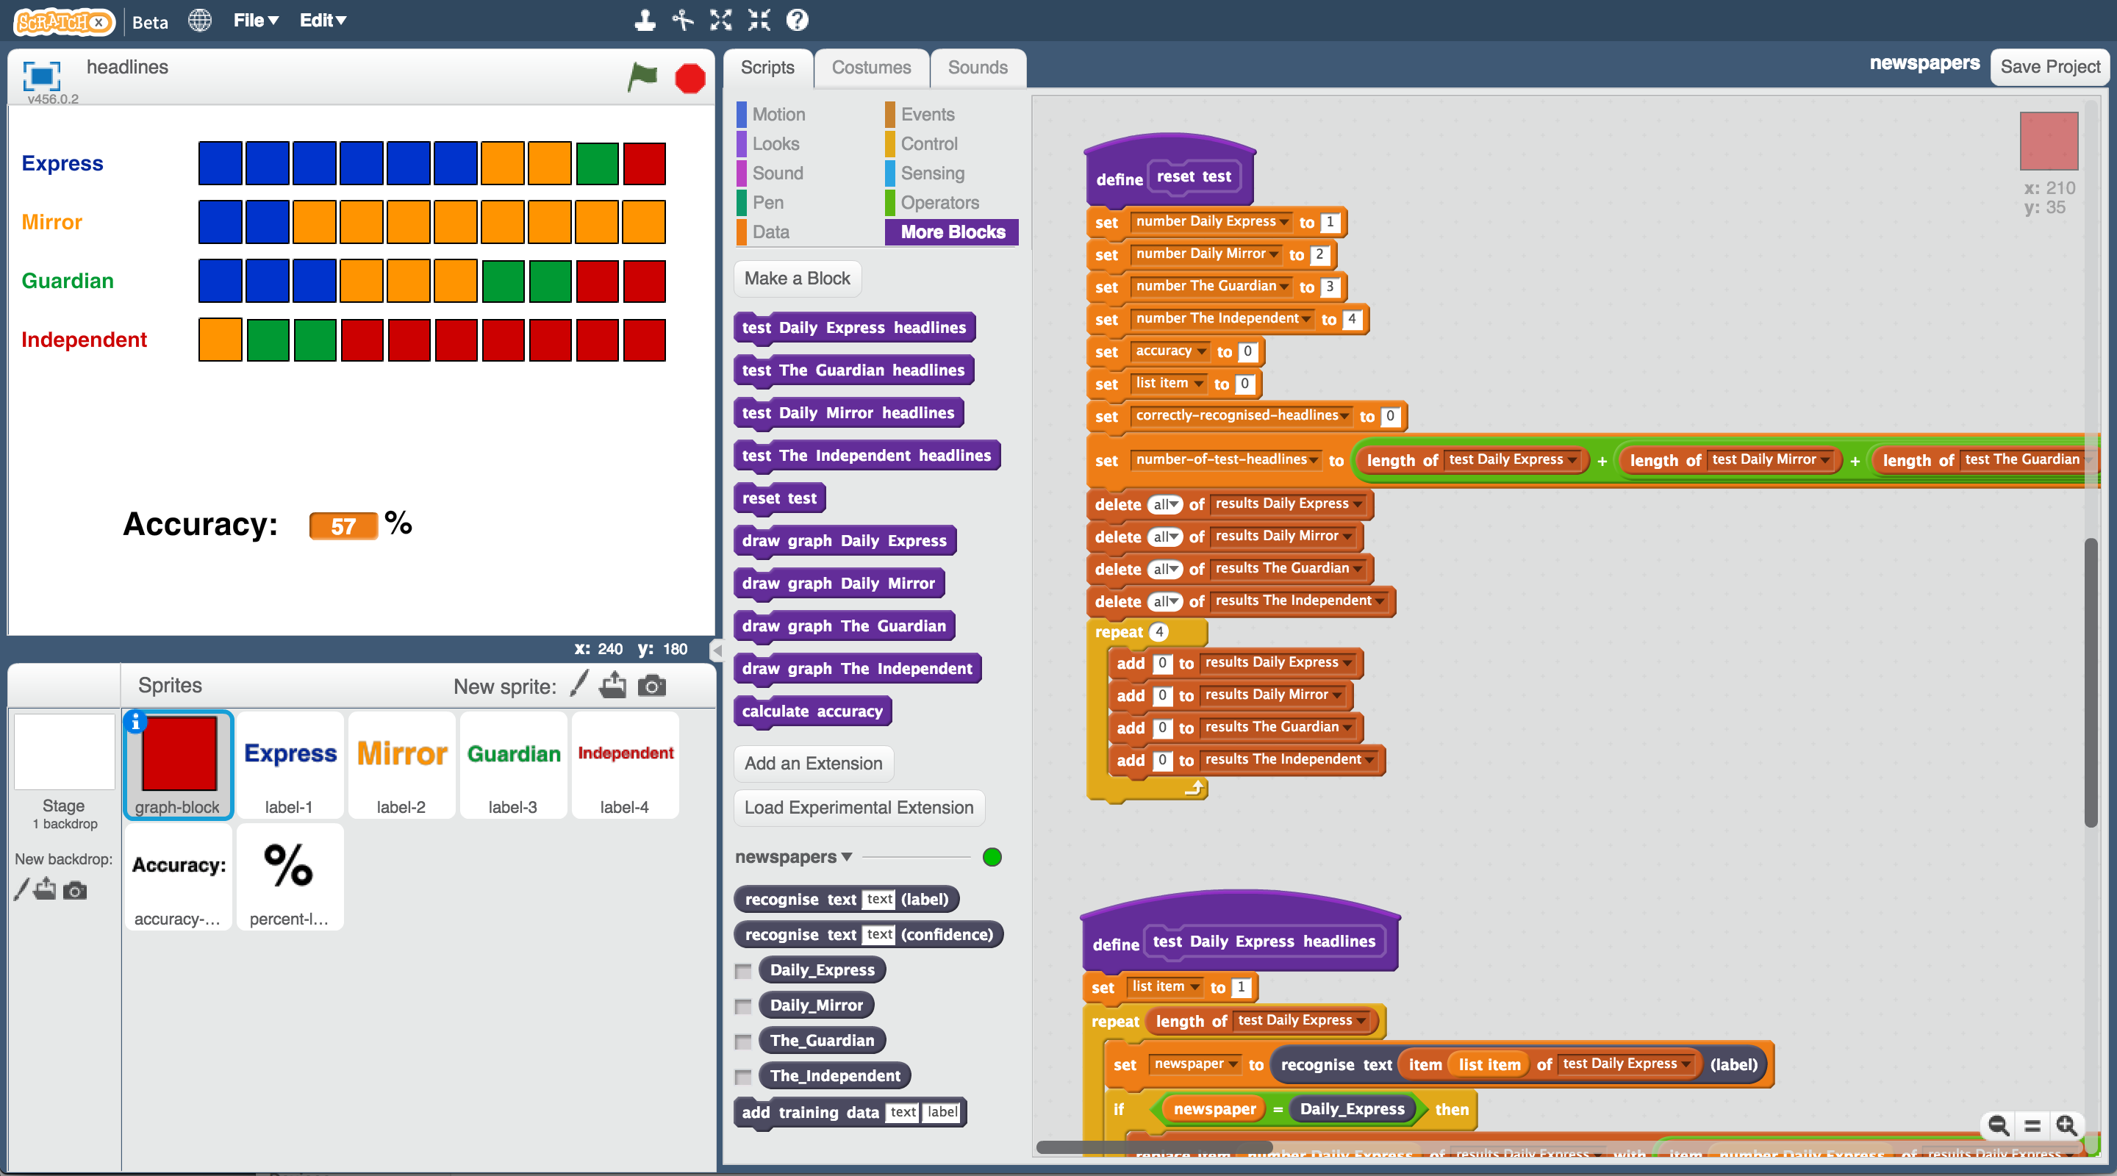

This project worksheet is licensed under a Creative Commons Attribution Non-Commercial Share-Alike License

http://creativecommons.org/licenses/by-nc-sa/4.0/

1. Go to <https://machinelearningforkids.co.uk/> in a web browser
2. Click on “**Get started**”
3. Click on “**Log In**” and type in your username and password  
   *If you don’t have a username, ask your teacher or group leader.*
4. Click on “**Projects**” on the top menu bar
5. Click the **“+ Add a new project**” button.
6. Name your project “newspapers” and set it to learn how to recognise “**text**”. Click “**Create**”  
   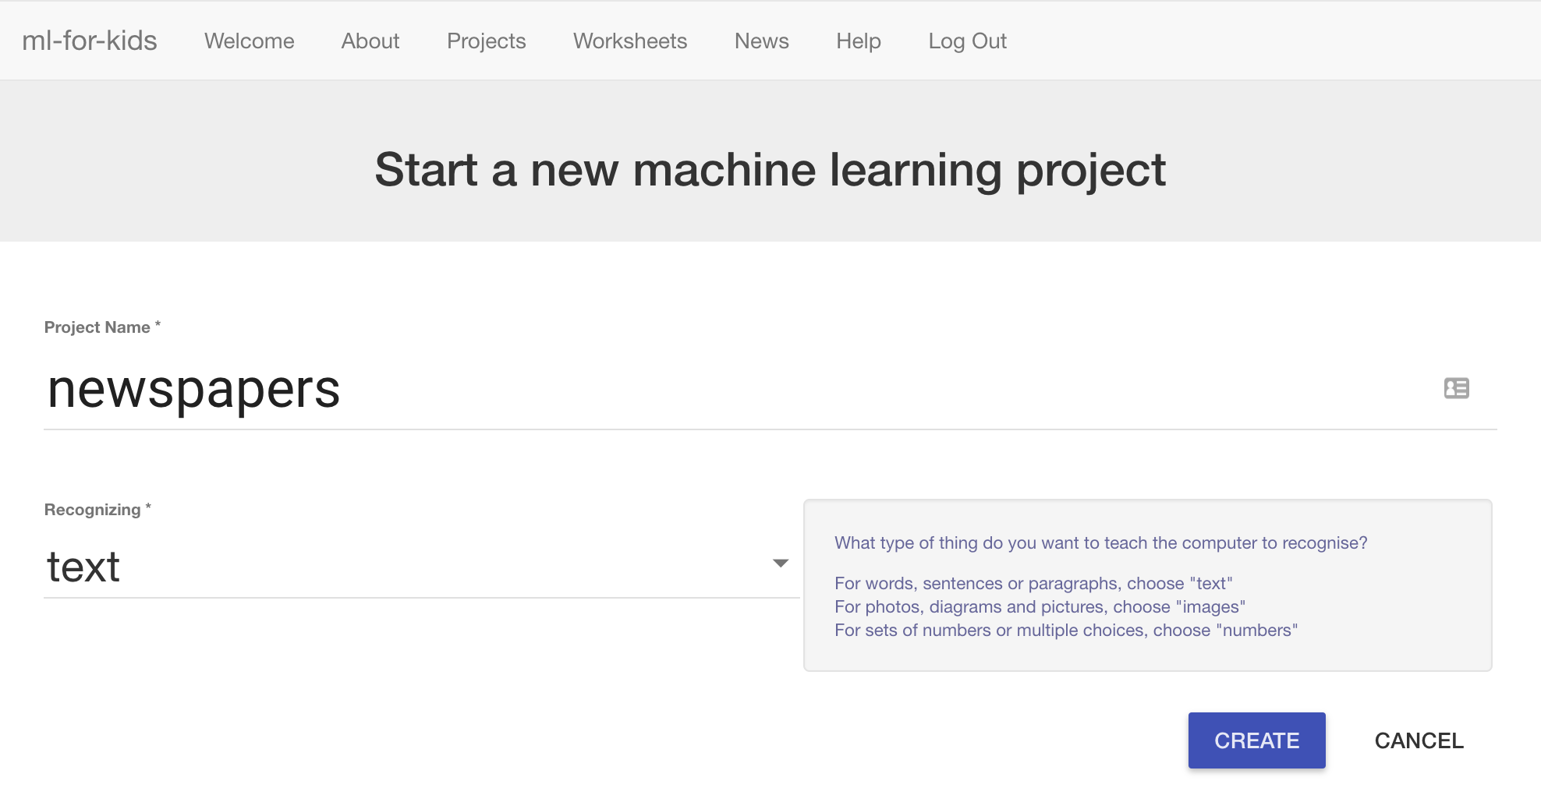
7. You should now see “newspapers” in your projects list. Click on it.  
   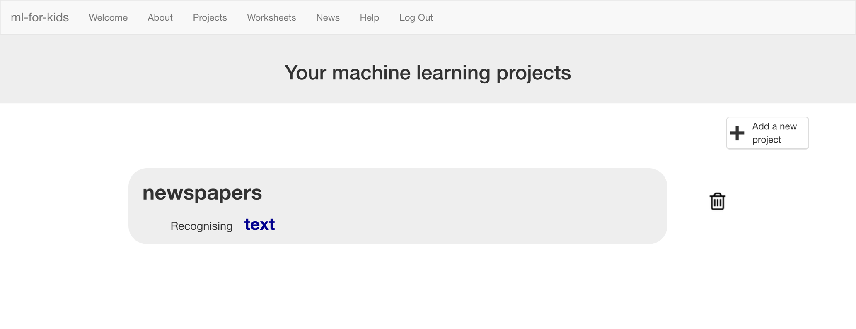
8. Click the “**Train**” button  
   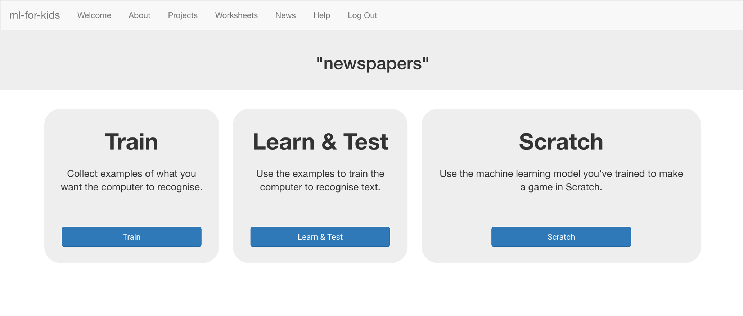
9. Choose four national newspapers.   
   *To save having to buy actual physical newspapers, you can use an online collection of newspaper front pages.   
     
   For the rest of this worksheet, I’ll be using:   
    Daily Express, Daily Mirror, The Guardian, The Independent  
   and getting the headlines from:* [*https://www.thepaperboy.com/uk/front-pages.cfm*](https://www.thepaperboy.com/uk/front-pages.cfm)
10. Use the “**+ Add new label**” button to create a bucket for each newspaper you’re using.  
    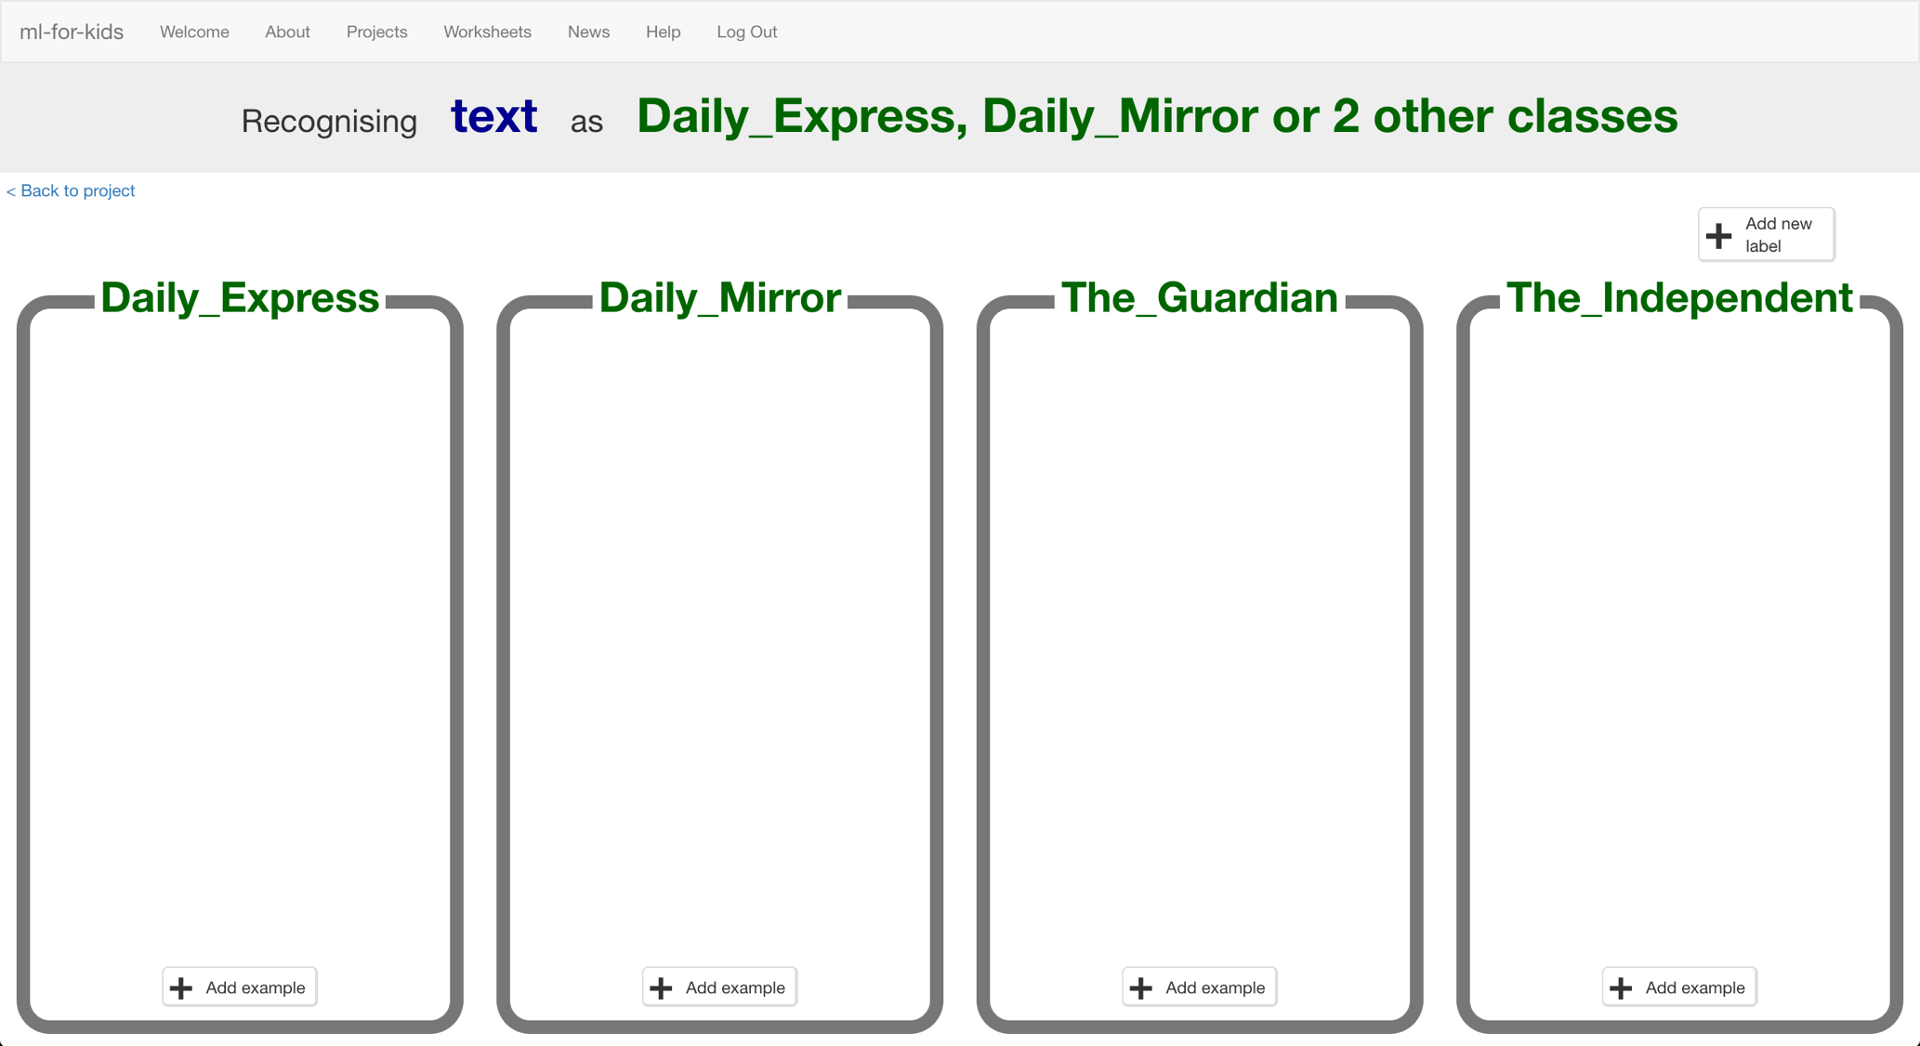
11. In another web browser window, find newspaper front pages.  
    *Arrange the windows so your training buckets are next to the book site.*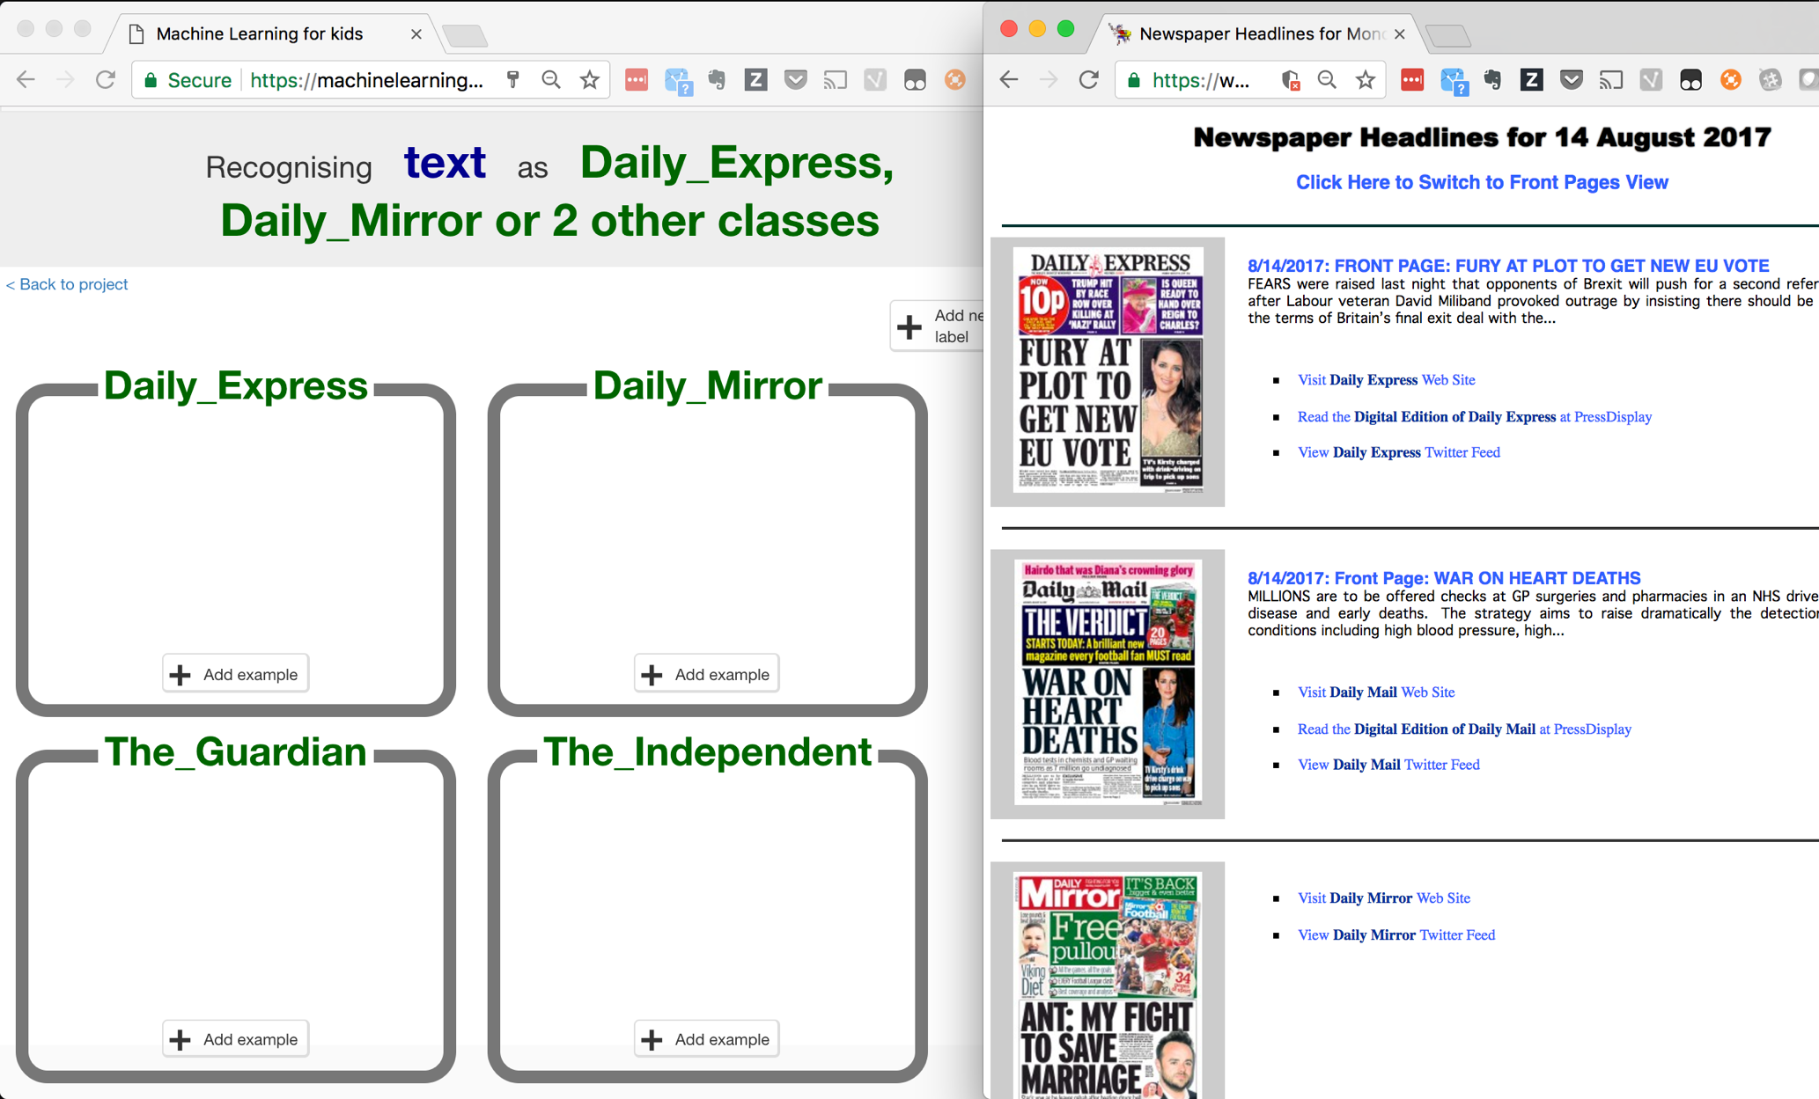
12. Agree on some rules for the examples of headlines that you’ll collect, so that the training is consistent.   
    *For the rest of this worksheet, I’ll be using:   
    * Newspapers from weekdays only (Mon-Fri) not weekend editions  
    * Only the biggest main headline from each newspaper*
13. Click the “**+ Add example**” button in one of the buckets and copy the newspaper headline into the “Add new example” dialog.   
    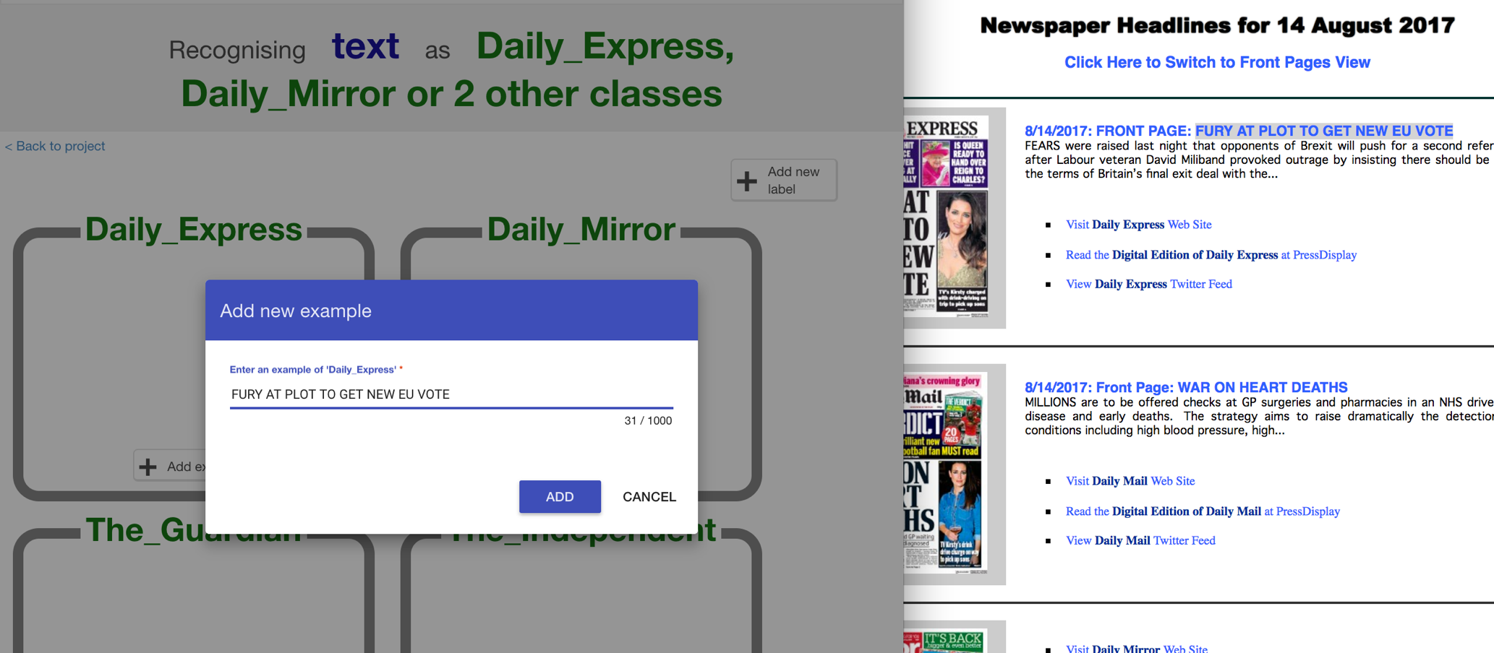
14. Repeat this for all four newspapers on this day  
    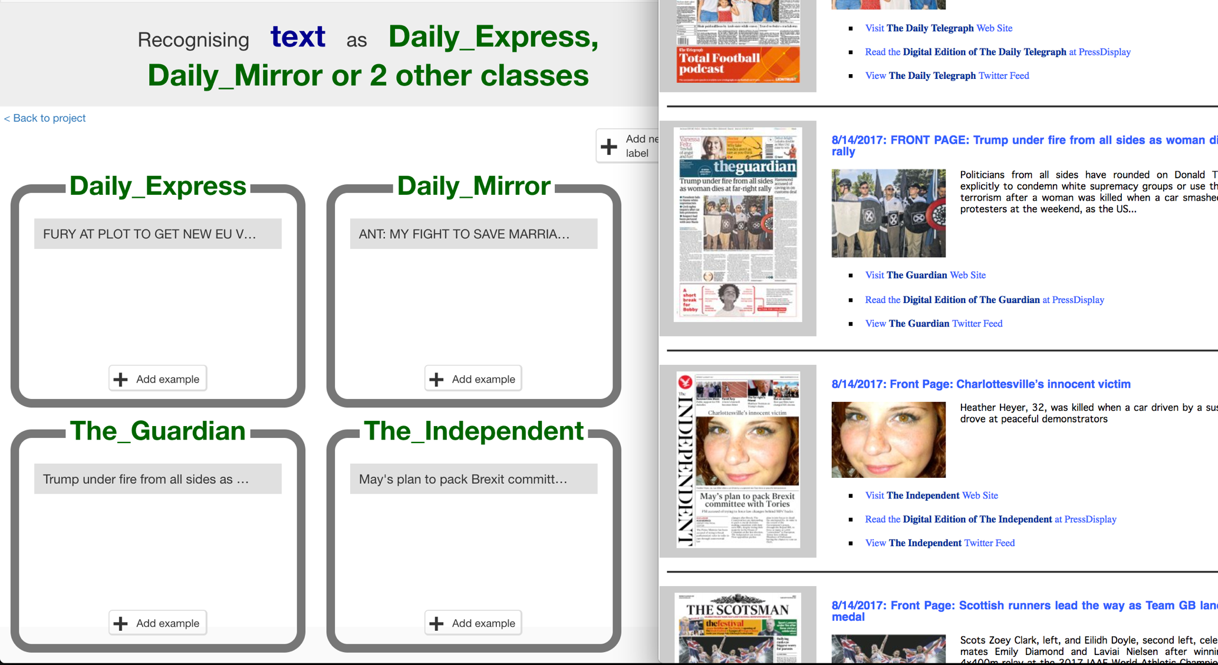
15. Repeat this for five days of newspaper headlines.   
    *If you’re using front pages from thepaperboy.com you can use the calendar at the bottom of the page to switch to a different day.  
    Remember the rules: Weekdays only. Biggest headline you see.  
    Tip: Use the ‘Front Page Headline View’ to get some headlines as text you can copy to save you some typing.*
16. You should now have examples from one week of newspapers  
    *Keep the newspaper site window open – you’ll need it again later.*  
    
17. Click the “**< Back to project**” link. Then click “**Learn & Train**”
18. Click “**Train new machine learning model**”.  
    *As long as you’ve collected enough examples, the computer should start to learn how to recognise headlines from the examples you’ve given to it.*
19. Wait for the training to complete. This might take a few minutes.
20. Try the model out by putting a headline into the **Test** box  
    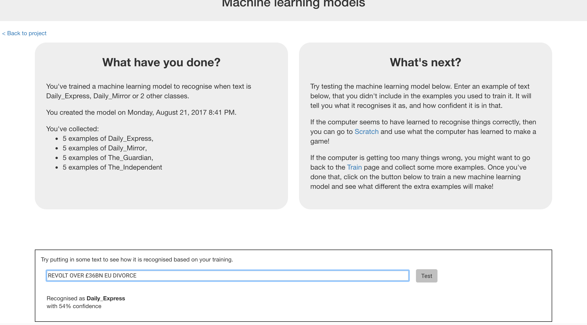

**What have you done so far?**

You’ve started to train a machine learning model to recognise patterns in the way that different newspapers use words, phrasing and punctuation in their front-page headlines.

But is it working well? How much has it learned so far? Does it need more examples to be able to recognise headlines correctly?  
What is it good at? What is it bad at? Which newspapers does it get confused between?

To answer those questions, you need to test the machine learning model. Next, you’ll build a test in Scratch to do this.

1. Click the “**< Back to project link**”. Then click “**Scratch**”.  
   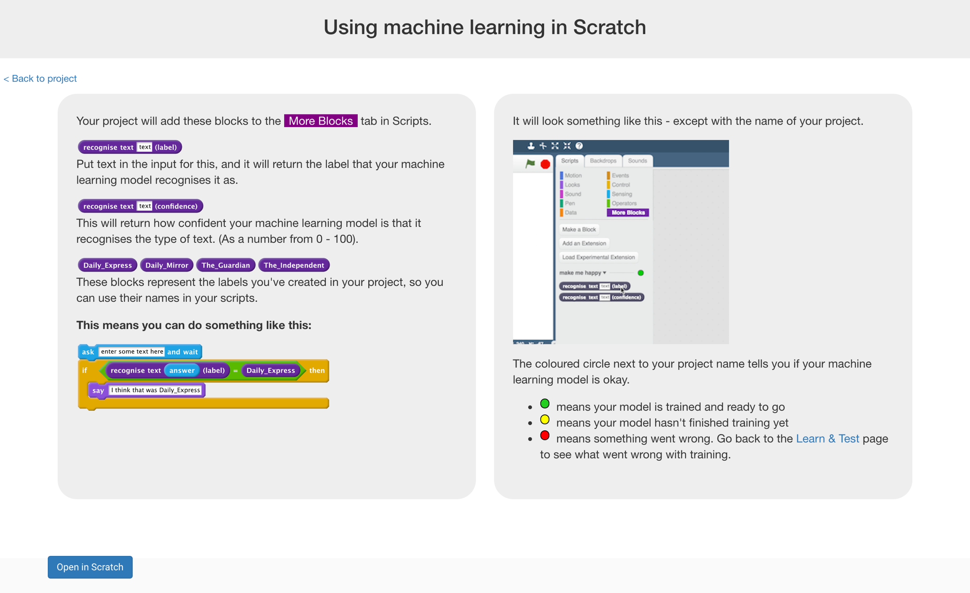
2. Click the “**Open in Scratch**” button to start making the test.  
   *You should see new blocks in the “More blocks” section from your “newspapers” project.*  
   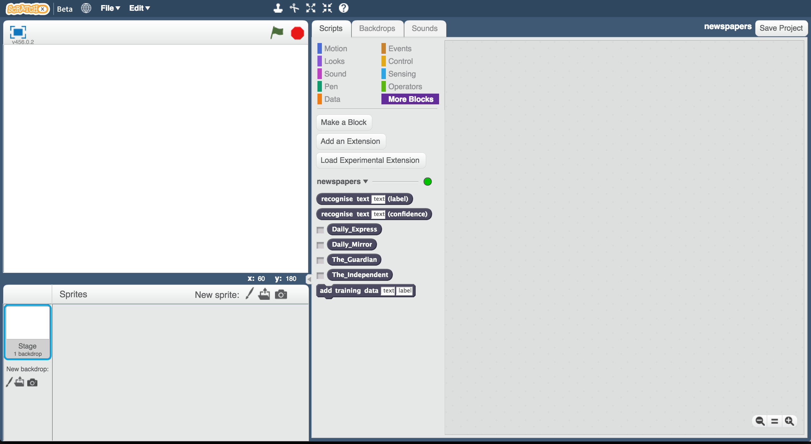
3. Open the Headlines project template   
   *Use* ***Project templates*** *->* ***Headlines***

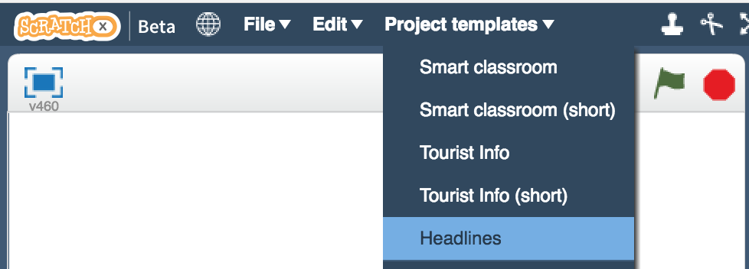

1. Click on the **Costumes** tab of the graph-block sprite.   
   Rename the costumes, so instead of being called “newspaper-1”, “newspaper-2”, etc. they have the names of your four newspapers. 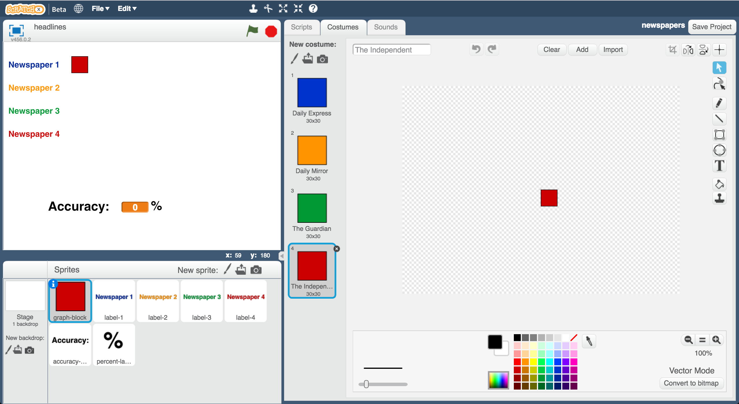
2. Update the text in the label-1, label2, label-3, label4 sprites   
   *Make sure that they match the order, and the colours, for the names you put in the graph-block sprite  
   Click on the costume using the T text tool to change the text.  
   You can use a shorter version of the names if it helps them fit better.*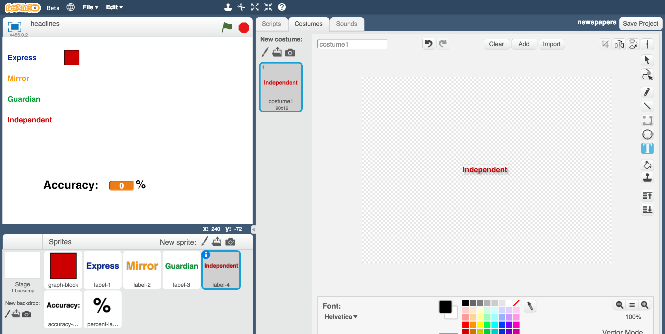
3. You will need **10** more front-page headlines from each newspaper.   
   Note: It is very important that none of these are examples you used to train the model.   
   *Ten more examples means another two week’s worth of newspapers.*
4. Click the **Data** tab, and then click the **Make a List** button   
   Create a list called “test Daily Express” for all sprites.  
   *If you’re using different newspapers, use the name of your first newspaper*
5. Enter your 10 test headlines from that newspaper.   
   *Resize the list window to make it bigger: that’ll make it easier to type into  
   Click the + button in the bottom left corner to add each new test headline*  
   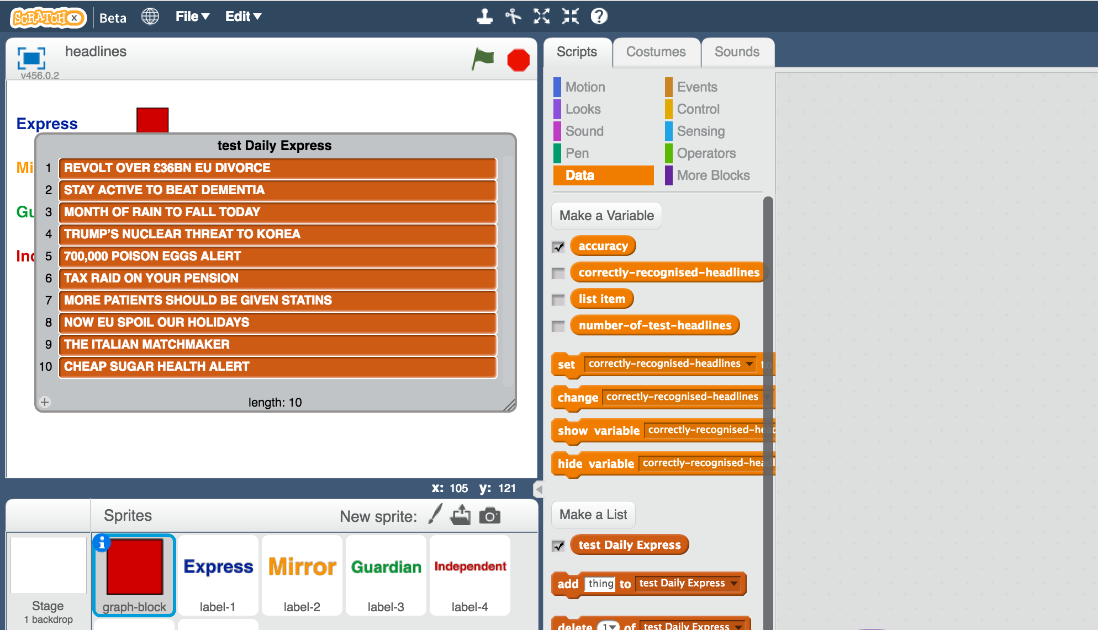
6. Untick the “test Daily Express” list so that it is hidden
7. Click the **Make a List** button again, and create a second list for your second newspaper. Call it “test Daily Mirror”   
   *If you’re using different newspapers, use the name of your second paper*  
   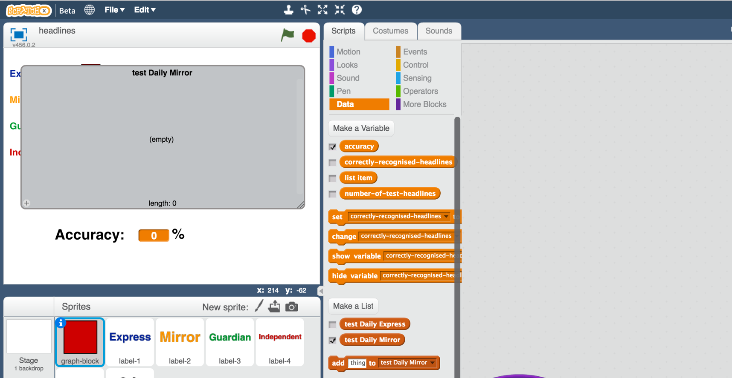
8. Type the 10 test headlines from your 2nd newspaper into this list.
9. Untick the list so that the second list is hidden like the first
10. Repeat for the third newspaper  
    *Create a new list with a name that starts with “test”. Add the ten test headlines from the third newspaper to the list.   
    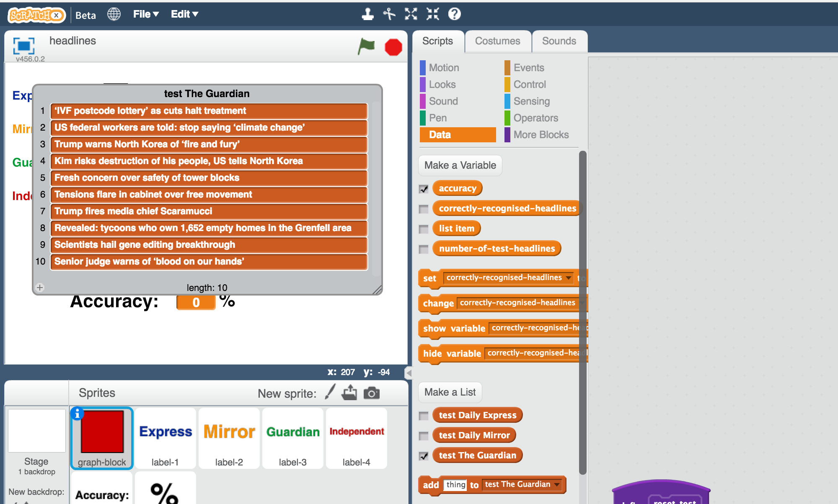*
11. Hide the third list by unticking it
12. Repeat for the fourth newspaper  
    *Create a new list with a name that starts with “test”. Add the ten test headlines from the fourth newspaper. Untick the list to hide it.*
13. Create four new variables   
    *Create a variable by clicking the* ***Make a Variable*** *button on the Data tab.*  
    *Create them for all sprites. Untick them so that they are hidden.   
    Name them “number Daily Express”, “number Daily Mirror”, etc. (using the names of your four newspapers).*  
    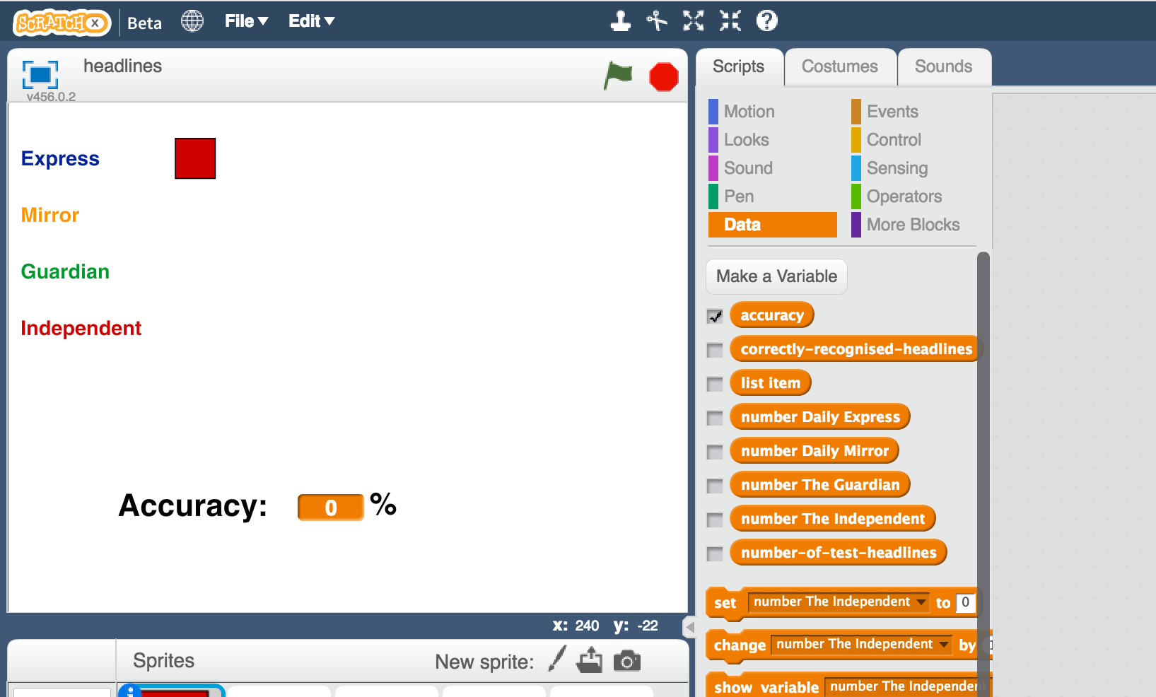
14. Create four new lists  
    *Create a list by clicking the* ***Make a List*** *button on the Data tab.*  
    *Create them for all sprites. Untick them so that they are hidden.  
    Name them “results Daily Express”, “results Daily Mirror”, etc. (using the names of your four newspapers).*  
    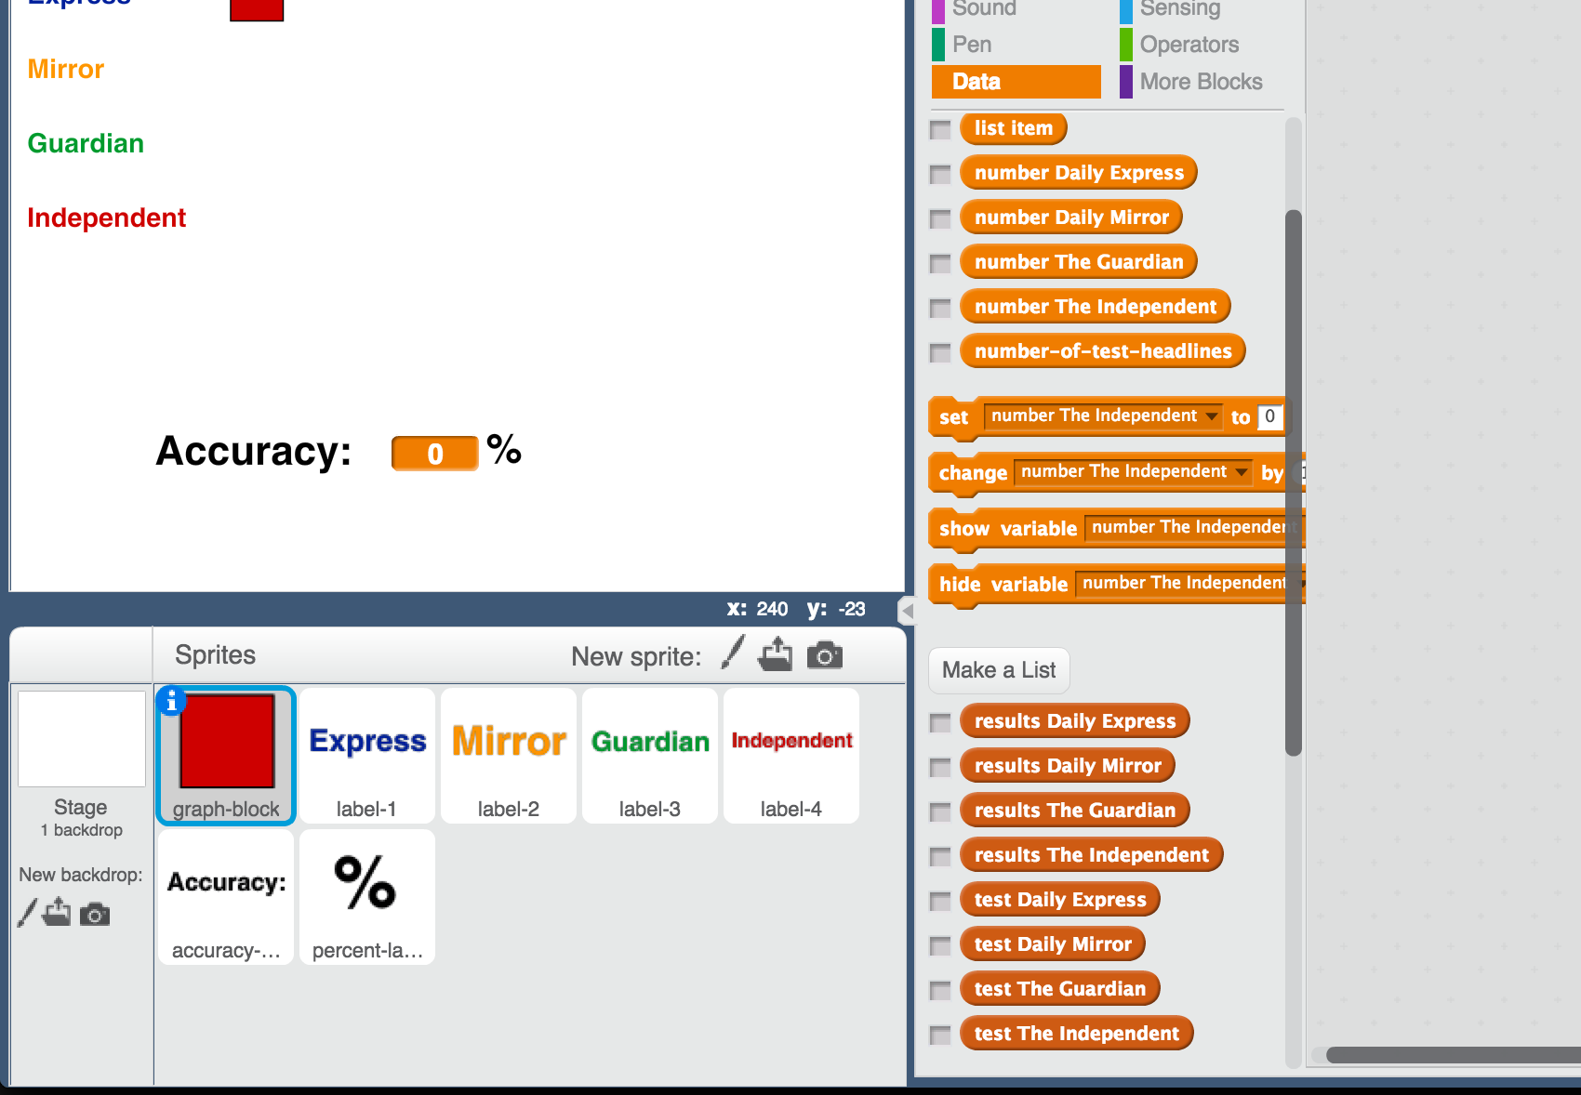
15. 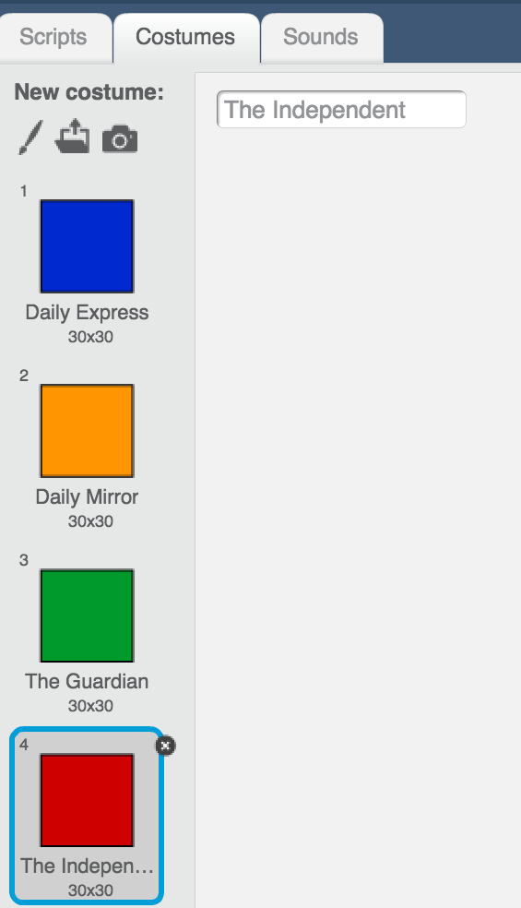Update the script for the **reset test** block to reset the data  
     *The numbers for the first four blocks (1,2,3,4)   
    should match the costume numbers for the   
    newspapers in graph-block. This also means   
    they should be in the same order as the   
    labels on the stage.*   
    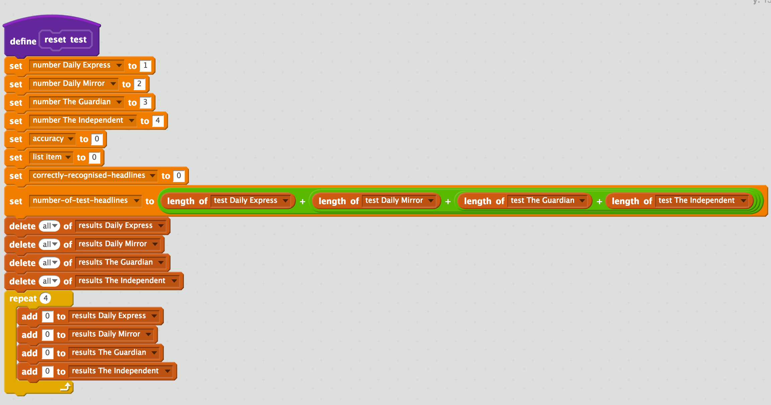  
    *The final ‘4’ in the repeat block is because there are four newspapers.*
16. Create a new variable called “newspaper”. Untick it to hide it. 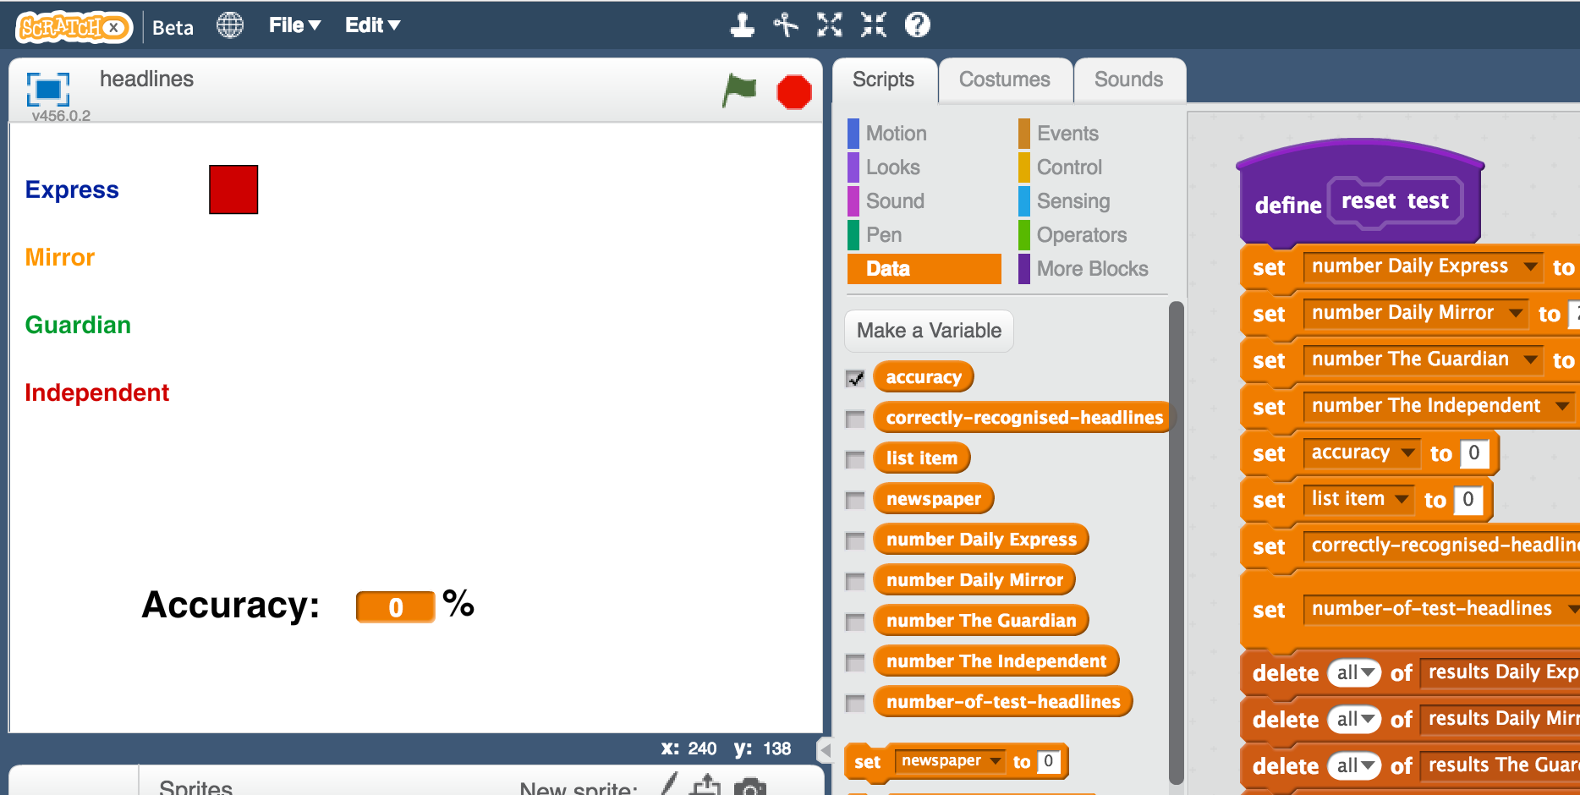
17. Create a new block to test your first newspaper  
    *Click on the graph-block sprite. Click the* ***Scripts*** *tab.   
    Click the purple* ***More Blocks*** *item. Click the* ***Make a Block*** *button.   
    Name it “test Daily Express headlines”*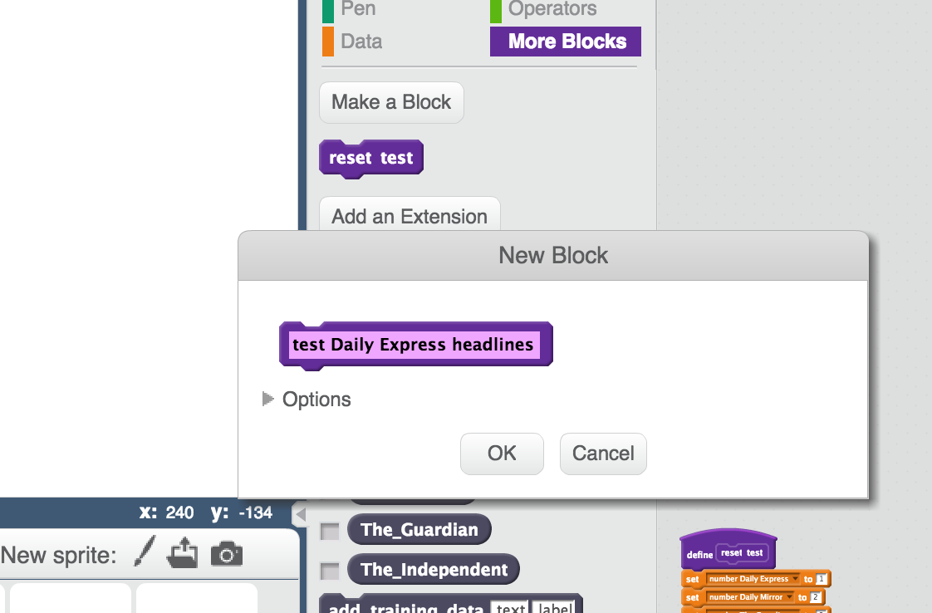
18. Enter the following script into the new custom block  
    *It will run your test headlines from the Daily Express through your machine learning model, and count the results it returns.*  
    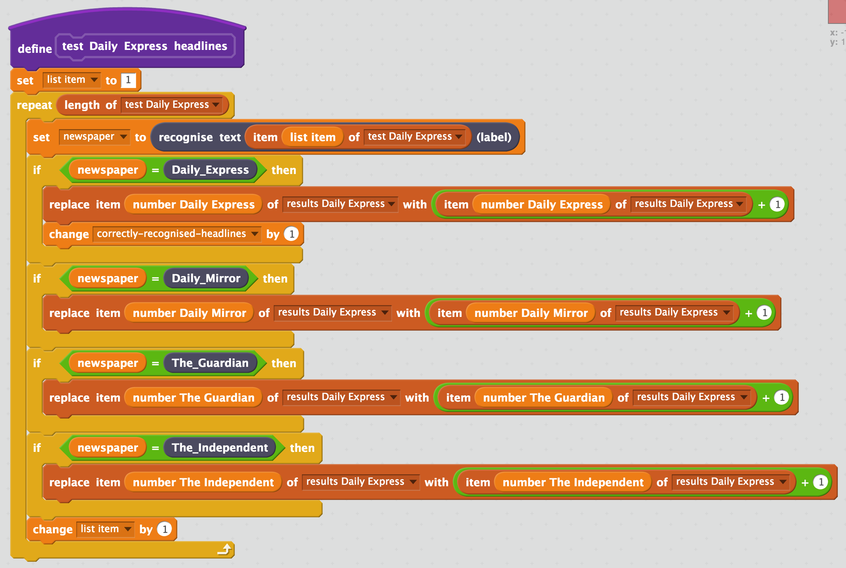
19. Create a new block to test the headlines from your second newspaper  
    *Click on the graph-block sprite.   
    Click on the* ***Scripts*** *tab. Click the purple* ***More Blocks*** *item.   
    Click the* ***Make a Block*** *button. Name it “test Daily Mirror headlines”*
20. Add the following script to the custom block.   
    *Notice how similar it is to the last one.   
    You can save yourself some time by duplicating the contents of your last script (right-click on the contents and click on Duplicate).   
    If you do this, make sure you update it to use the Daily Mirror lists and   
    also make sure you move the correctly-recognised-headlines block.*   
    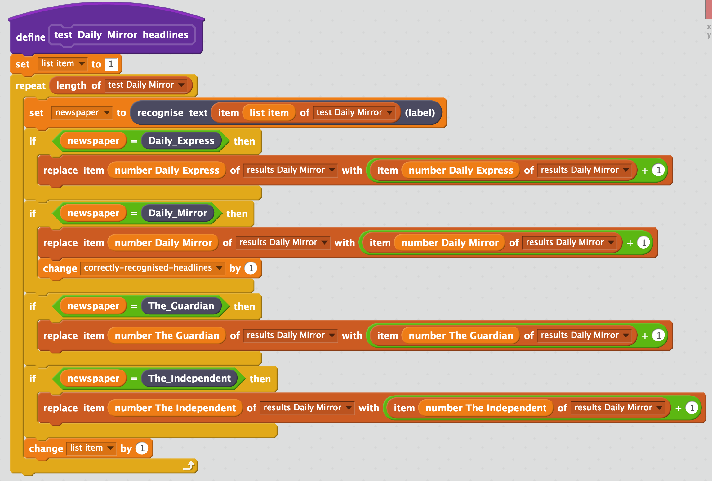
21. Create two more custom blocks to test the third and fourth newspapers.  
      
    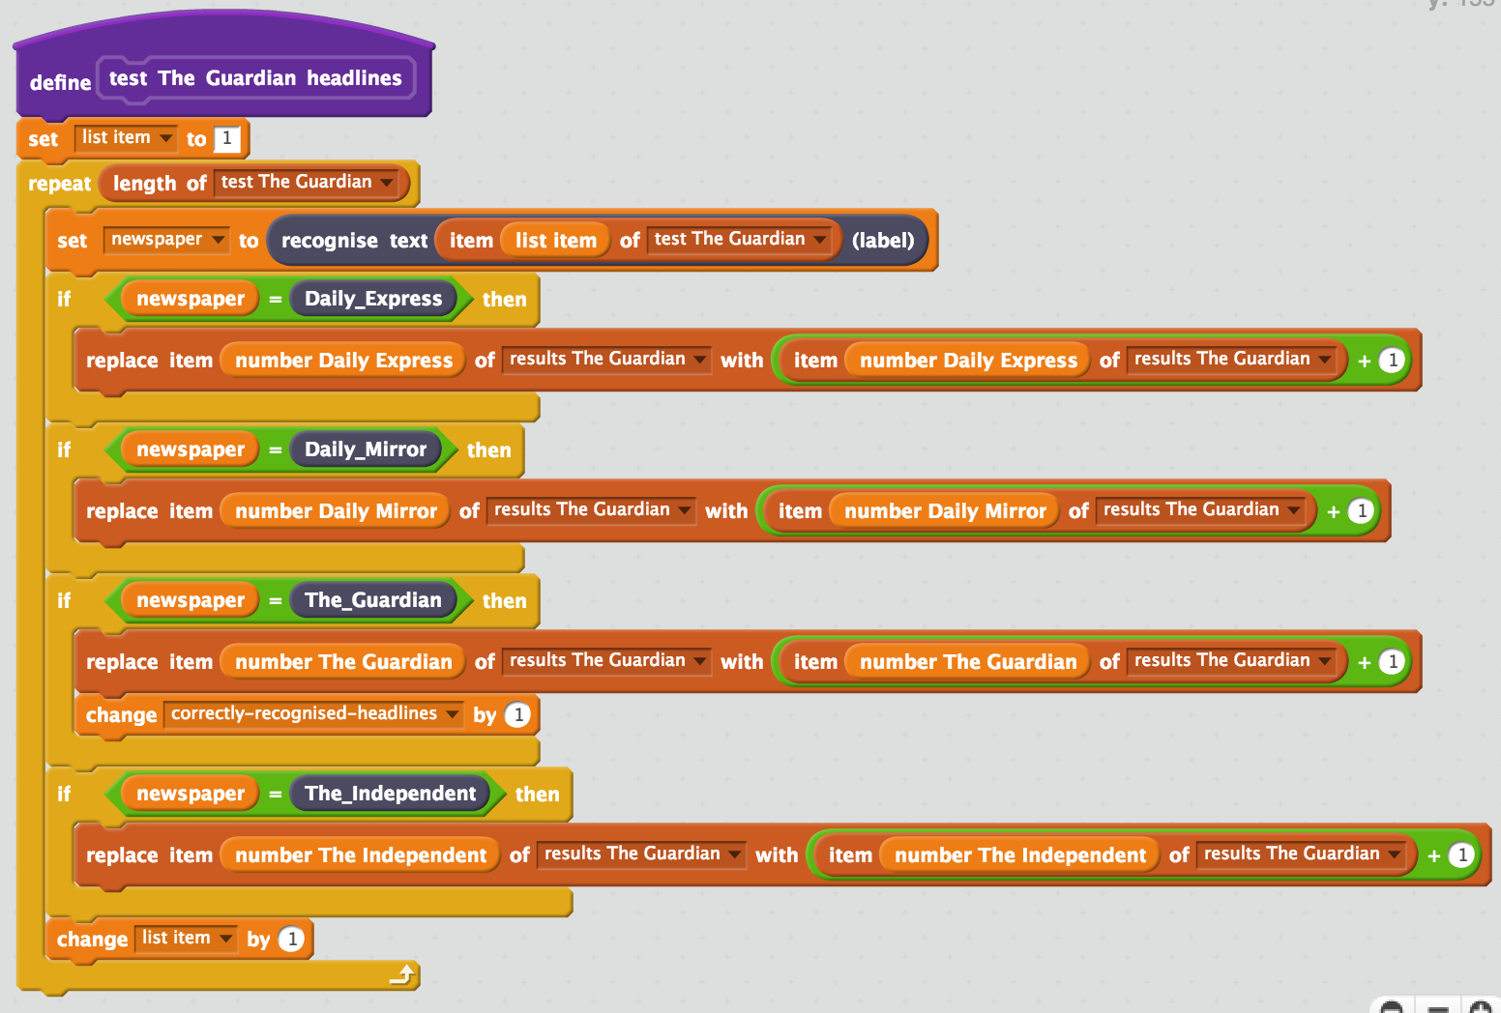  
      
    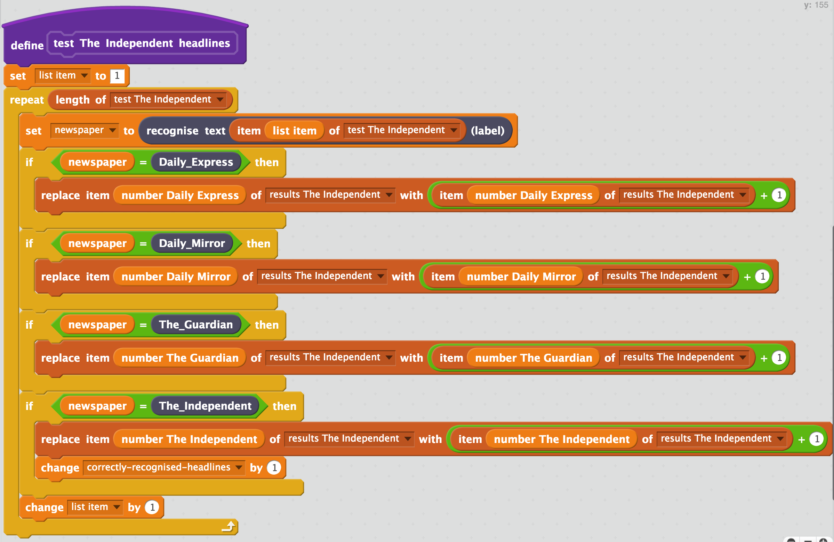
22. Create a new block to draw a graph of the results from the test of the headlines from the first newspaper  
    *Click on the graph-block sprite.   
    Click on the* ***Scripts*** *tab. Click the purple* ***More Blocks*** *item.   
    Click the* ***Make a Block*** *button. Name it “draw graph Daily Express”*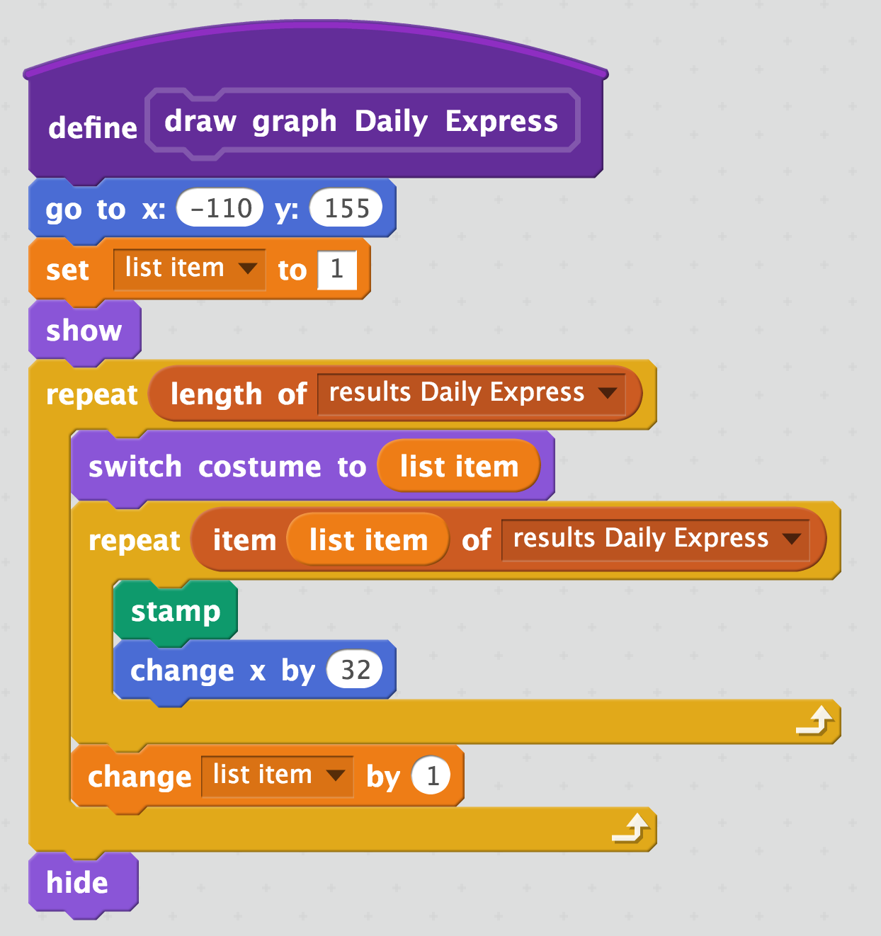
23. Create blocks to draw graphs for the other three newspapers.  
    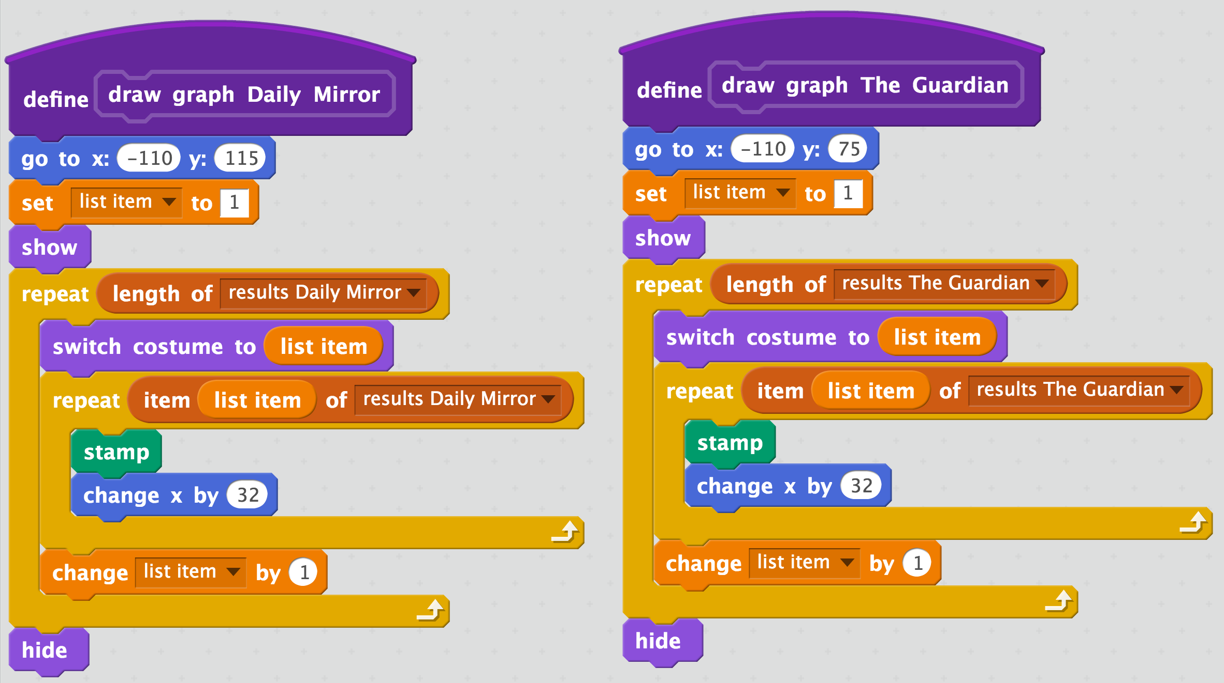  
    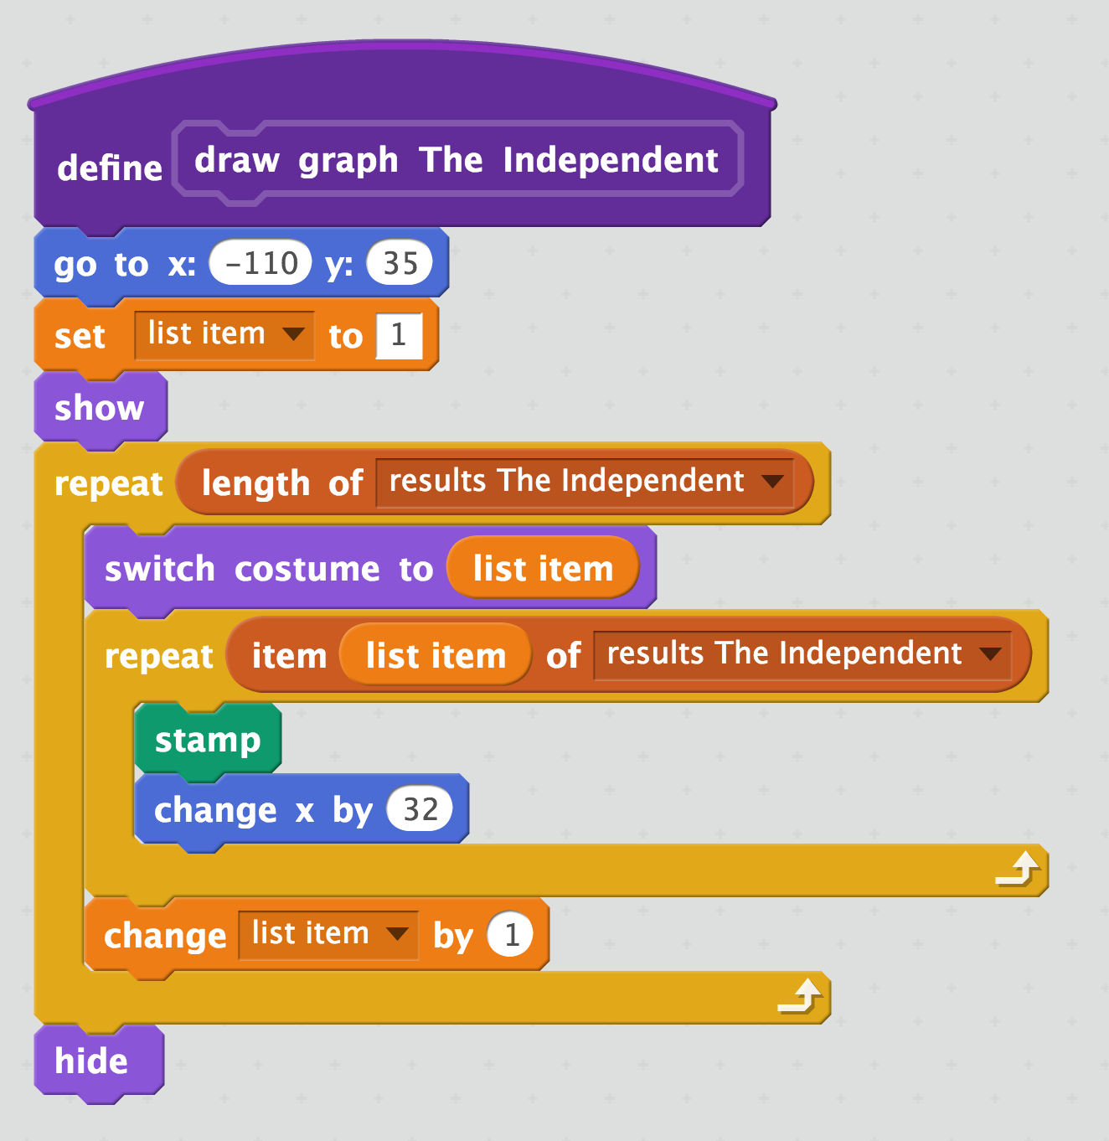
24. Create a new block to calculate how accurate your machine learning model is  
    *Create this block in the graph-block sprite along with all the other scripts.*  
    *This calculates how many headlines are correctly recognised as a percentage.*  
    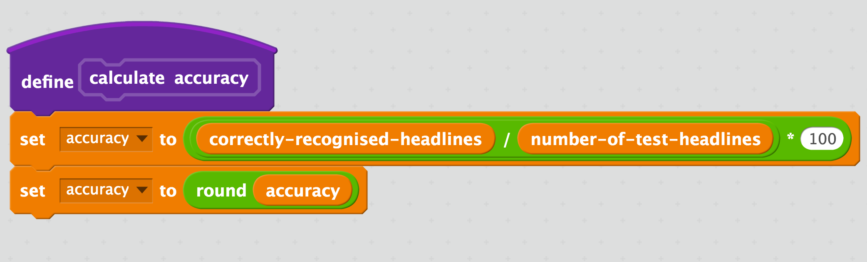
25. Time to put it all together!  
    *Create this script in the graph-block sprite.   
    It will test your machine learning model using all of your test headlines from all the papers.   
    It will draw a graph to show you the results, and calculate the overall accuracy to give you a score.*  
    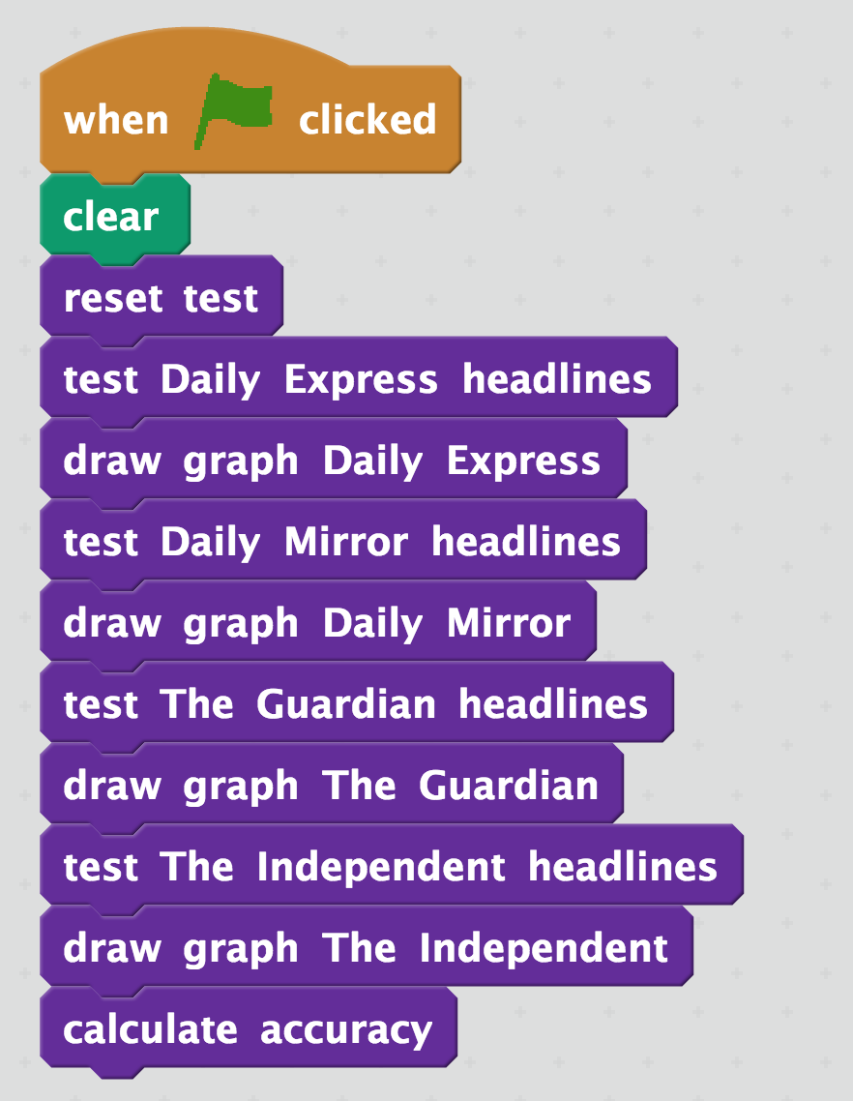
26. 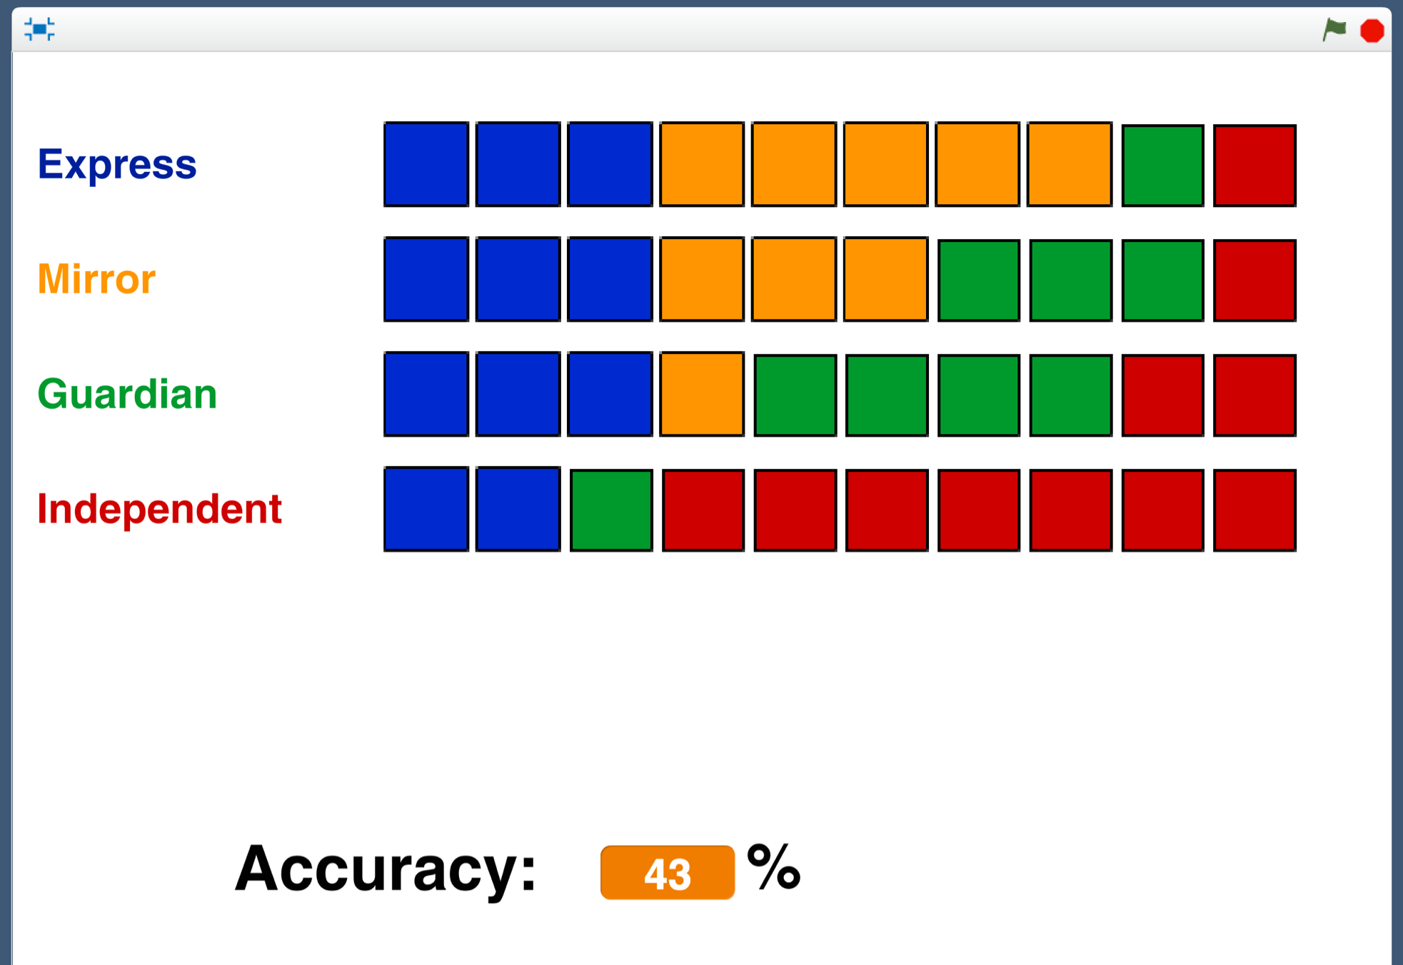Run the test  
    *Click the green flag, and watch it run.*Each row is made up of 10 blocks.   
      
    The 10 blocks represent the 10 test headlines from a newspaper. *  
    I collected 10 headlines from front-pages of The Independent.   
    My machine learning model “thought” 2 of them of them were from the Daily Express (blue).   
    It “thought” that 1 of them was from The Guardian (green).   
    It correctly recognised the other 7 as being headlines from The Independent.   
    That was pretty good!*  
      
      
    *I collected 10 headlines from front-pages of the Daily Express.   
    The machine learning model correctly recognised 3 of them.   
    It thought 5 were from the Daily Mirror, 1 was from The Guardian, and it thought 1 looked like a headline from The Independent.*  
    *Not so good. It looks like it’s having trouble telling the difference between Daily Express and Daily Mirror headlines.* *Overall, my machine learning model correctly recognised 43% of the test headlines.*

**What have you done so far?**

You’ve started to train a machine learning model to recognise newspaper front-page headlines. You’ve given it a very small number of examples to learn from – only a single week’s worth of newspapers.

You’ve created a test for your model in Scratch. This test is like an exam for the model, testing how well it does on headlines it hasn’t seen before.

It marks how well the machine learning model does. It draws graphs to help you understand what it is good at, and what it’s not good at.   
  
The next step is to try and improve the test result by giving our machine learning model some more training. With more examples of headlines, it will hopefully do even better.

1. Save your Scratch project  
   *Click on* ***File*** *->* ***Save Project***
2. Switch back to the training tool window
3. Click on the **“< Back to project**” link.
4. Click the **Train** button
5. Repeat steps 13-15. Collect additional headlines from another couple of weeks of newspapers.   
   *Make sure you don’t use any headlines that are in your Scratch test.   
   If you show it an example that you’ll use to test the model, that won’t be a fair test.  
   You should now have fifteen example headlines from each newspaper.*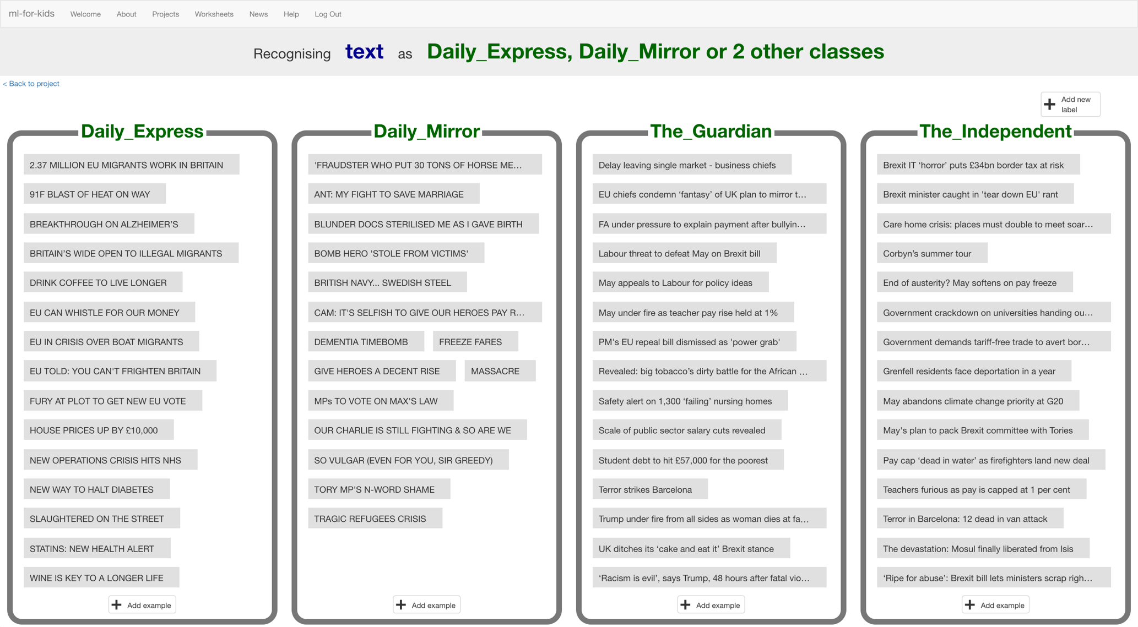
6. Click the “**< Back to project**” link. Click the **Learn & Test** button.
7. Click the **Train new machine learning model** button  
   *Wait for the training to complete. This might take a few minutes.*  
   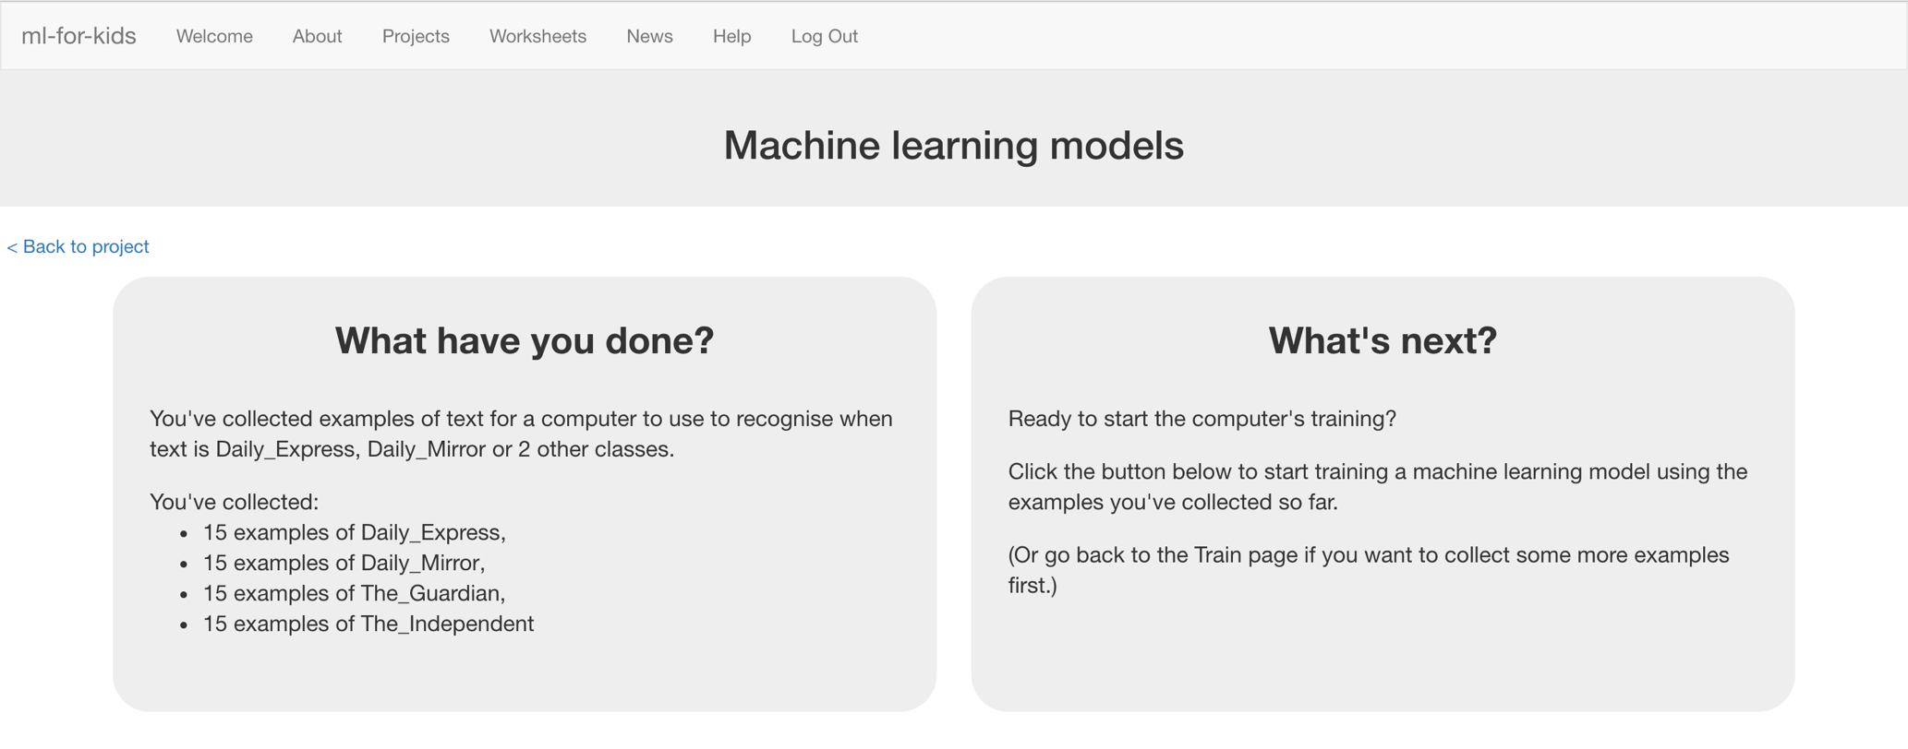
8. Switch back to the Scratch window.   
   *If you accidentally closed it, you can get back to it by doing this:  
   * Click the “****< Back to project****” link  
   * Click the “****Scratch****” button  
   * Click the “****Open in Scratch****” button  
   * Open the Scratch project you saved before, with “****File****” -> “****Load Project****”*

1. 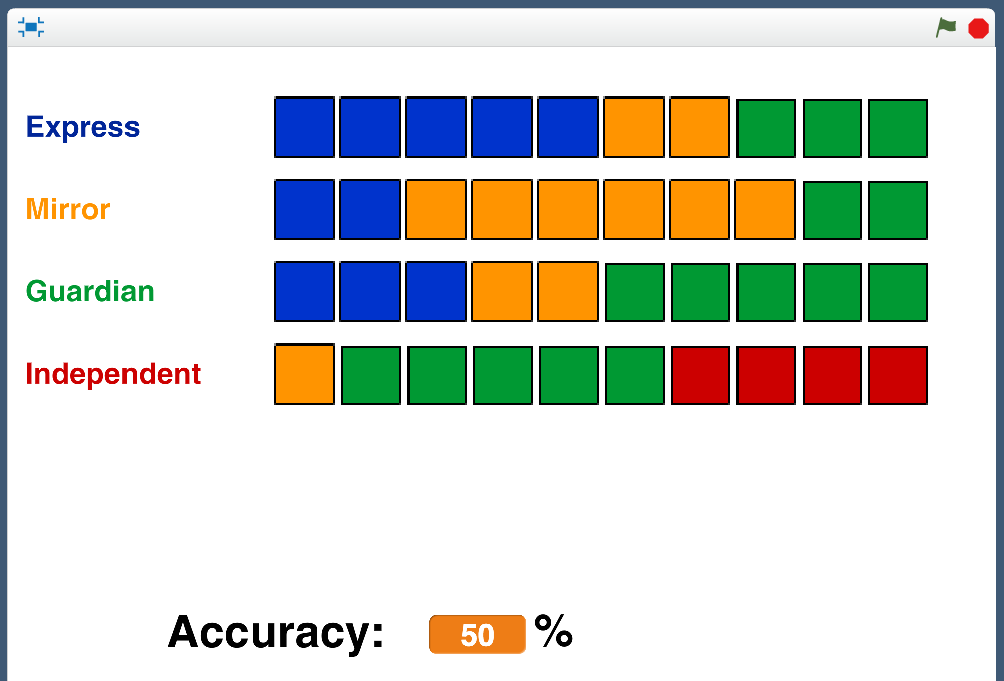Test your new model by clicking the Green Flag.  
   Compare the results with the results you got before.   
     
   *My results after fifteen examples were a little better overall.   
   It was a little better at recognising Express and Guardian headlines, and much better at recognising Daily Mirror headlines.   
   But it got a lot worse at recognising Independent headlines – getting wrong several that it was recognising correctly before!*
2. Repeat steps 51 – 58 again.   
   *Go back to the Training tool and collect more examples.   
   Train a new machine learning model.   
   Go back to Scratch and run your test to see how your new model is doing.*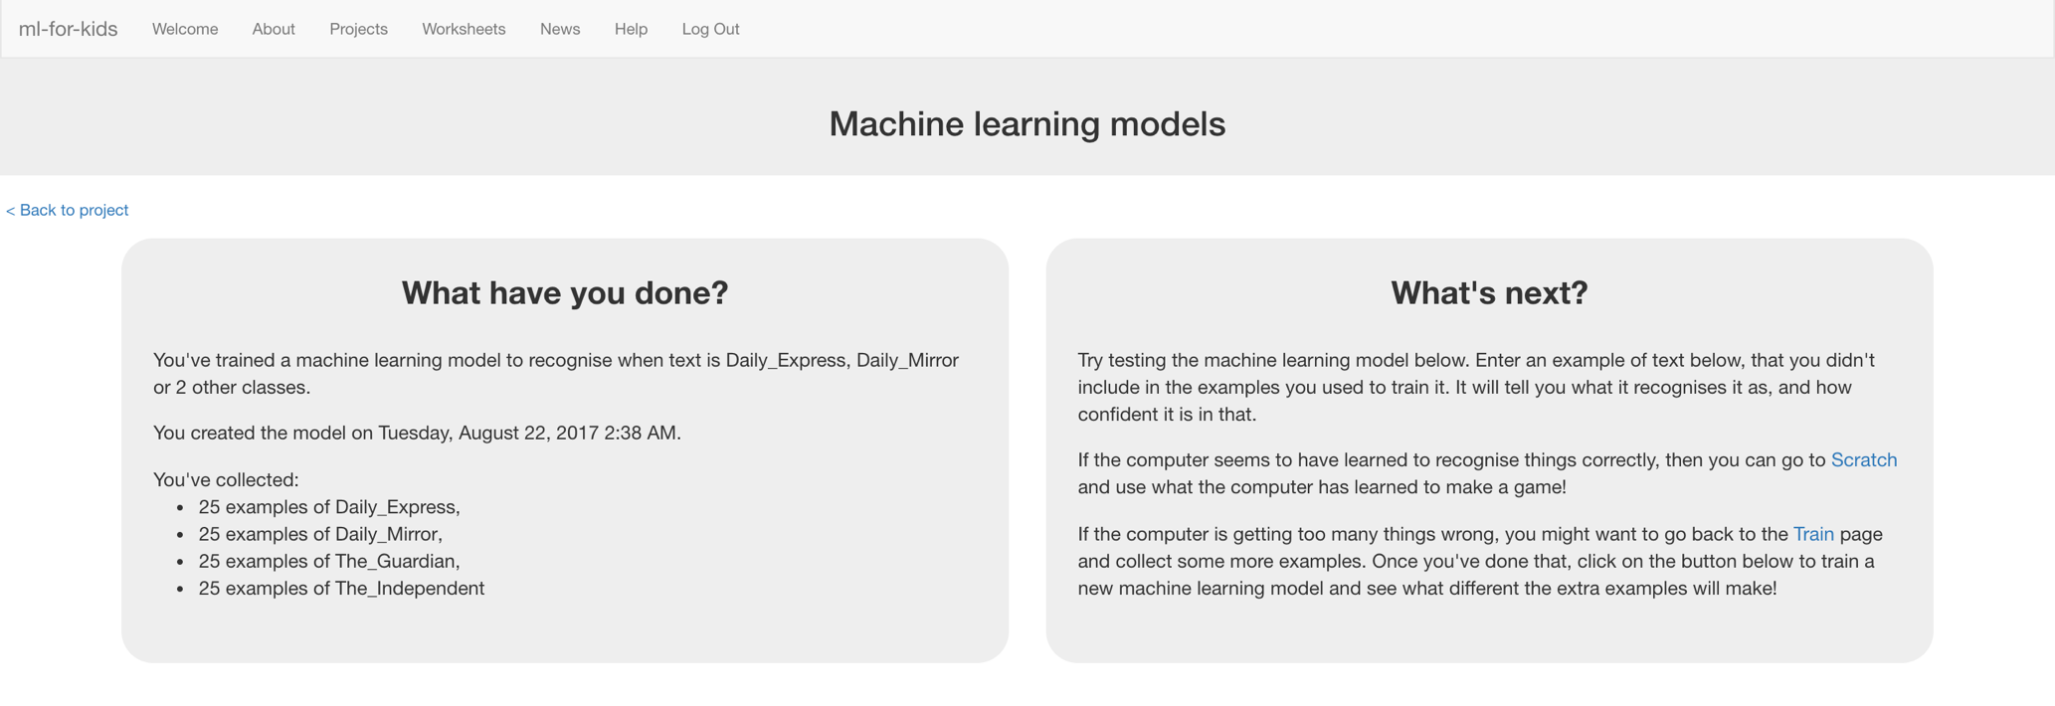  
   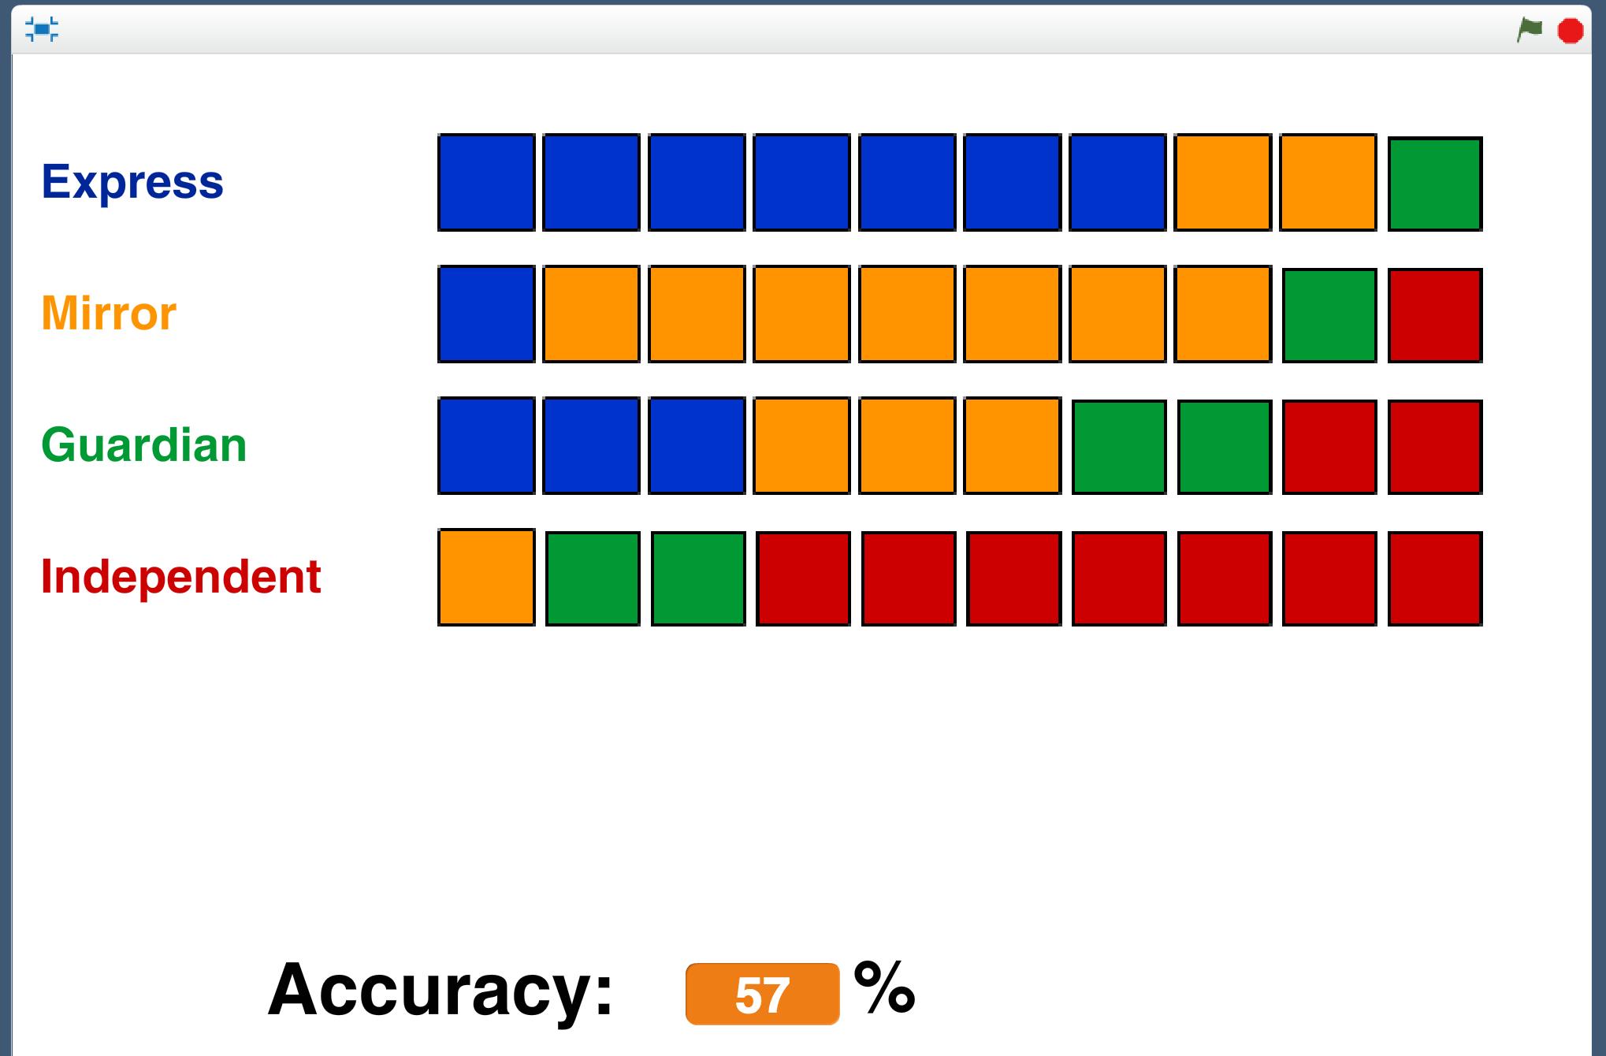  
    *A little better overall.   
     
   It got worse at recognising Guardian headlines, though.*

**What have you done?**

You’ve trained a machine learning model to recognise the use of language in the front page headlines of four national newspapers.

You’ve tested the model to assess the performance of the machine learning model.

You repeated this test at various stages of your model’s training to see how the performance improved as you continued to train it.

**Ideas and Extensions**

Now that you’ve finished, why not give one of these ideas a try?

Or come up with one of your own?

**Look for other patterns in newspapers**

Instead of comparing tabloid papers with broadsheet newspapers, try some other project ideas.

What about comparing local newspapers with national newspapers? Or weekend editions with week day papers?

**Try different numbers of newspapers**

What happens if you add additional newspapers? Is it still as good? What happens if you remove some, and only train it to tell headlines from two newspapers? Does it do better then?

**Use a bigger test**

Try running the test with 20 headlines from each newspaper instead of 10. What difference does that make?

**Use the confidence block in Scratch**

Think about how you could include the confidence that your machine learning model has in its predictions. Could your test treat predictions with high confidence differently from predictions that have a low confidence?